Chapter 1… Introduction
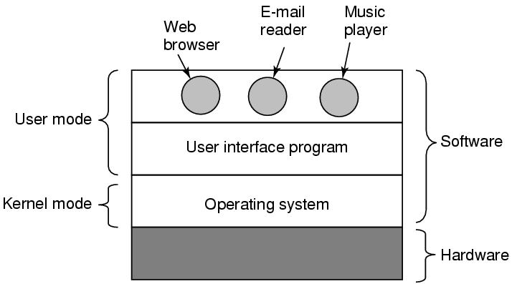
- OS as a layer (Fig 1.1 pg 16)
  - Hardware >OS>Shell or GUI allow user to lunch programs
  - Kernel Mode :
    - has access to all machine instructions
    - where operating system sets
    - can’t be replaced with another one ( e.g interrupt handler )
  - User Mode :
    - Where apps sets
    - limited access to machine instructions
    - applications can be added/replaced
- Main functions of OS
  - OS as an extended machine: providing an abstraction above ugly hardware interfaces and turning them into easy consistent abstracts for user programs to deal with ( files , process ,..)
  - OS as a resource manager : manages resources and provide them to many competing apps/users , like processor ,memory , I/O . it allows for resource multiplexing (sharing)
    - Time multiplexing: multiple apps can take turns using resource ( e.g CPU )
    - Space Multiplexing: Instead of taking turns they consume part of resource ( multiple apps each one take part in memory , or file system used by multiple users ) , OS handles and controls who can access which resource
- Hardware components
  - CPU : pipe line (fetch, decode ,execute) , Superscalar ( multiple Fetch, decode > buffer > multiple execute units)
  - Memory : register >L1Cache >L2Cahe >RAM>Disk >Tape ( time and capacity increases)
  - I/O : handling: allows OS to block caller App until I/O completes , other apps can run in meantime
    - via busy waiting : App>OS>driver>controller > hardware (loop and wait for certain bit )
    - interrupt Fig 1-11 pg 29
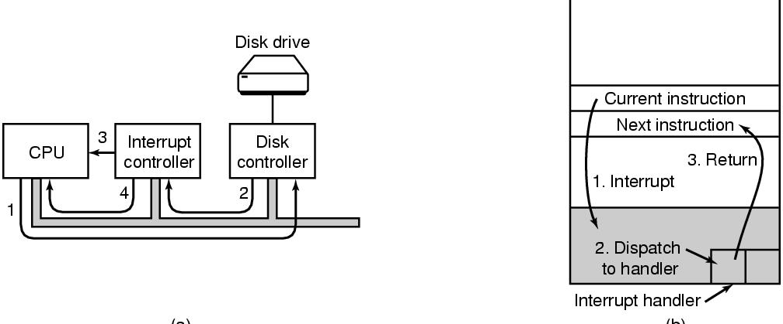
      - Driver tells controller what to do by writing into device registers
      - Controller starts the device actions
      - After it finish it interrupts the interrupt controller in chip
      - The interrupt controller interrupts CPU by asserting a pin on it
      - The interrupt controller puts also device number on bus for CPU to know about it
      - When CPU ready to handle , it switches to kernel mode , use device number to index the interrupt vector ( in memory ) , and call the interrupt handler
      - The interrupt handler finishes and return to the app calling procedure with results
    - DMA (direct memory access) , special HW
      - CPU tells chip which address , number of bytes , devices and direction
      - When DMA chip is done in generates interrupt to CPU and handled as above
- OS zoo
  - Mainframe operating systems
  - Server operating systems
  - Multiprocessor operating systems
  - Personal computer operating systems
  - Handheld operating systems
  - Embedded operating systems
  - Sensor node operating systems ( low power)
  - Real-time operating systems( must meet deadlines)
  - Smart card operating systems (extreme low resources)
- OS concepts( abstractions):
  - Process(CPU): a program in execution, contain address space ( could be virtual memory) , resources (open files) , can fork children , memory has process image , text and data . process table to hold these info .
    - 2 processes can communicate via a pipe
  - Files and directories(Disk) : permissions , paths , working directory , mounting
    - Special files to handle I/O , block(disk) and character based(printer)
    - Pipe is a pseudo file allows 2 processes to communicate
  - Protection rwx-rwx-rwx ( owner, owner group members, anybody else )
- System calls
- 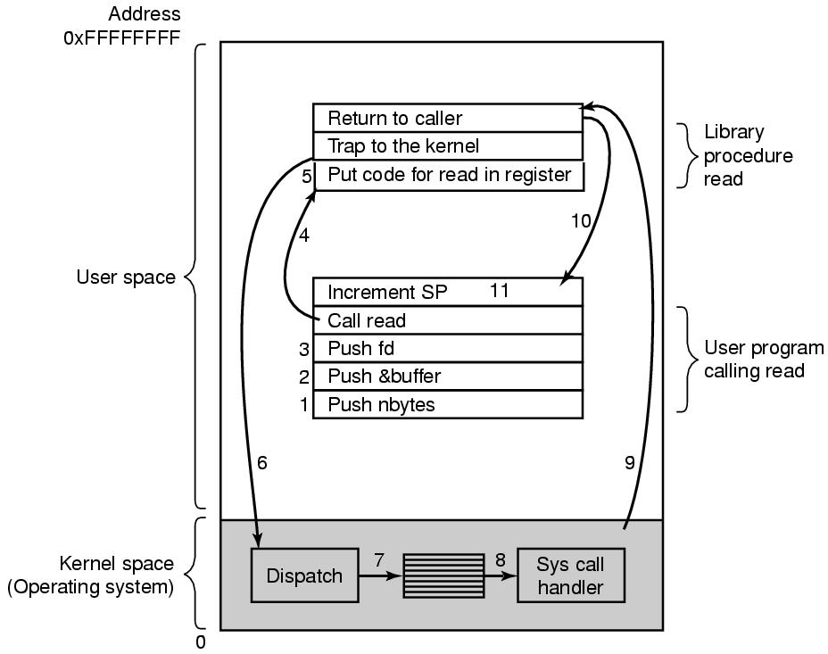
  - Steps:
    - User program calls read ( in C it’s a procedure in C library), push variables on stack
    - Library trap to the kernel ,put code in register
    - Kernel examines the trap , determine handler ( via a table of handlers as per Trap number)
    - Handler returns to library
    - Library return result to user App
    - It could happen after Trap Kernel (OS) will block caller (for I/O) and run something else
  - Trap instruction vs procedure call :
    - Trap switches mode from user mode to Kernel mode
    - Trap jumps to a fixed location
- Process system call samples :
  - Fork : create a child process identical to parent
  - Waitpid , wait for child to complete
  - Execve :replace process core image
- Simple Shell
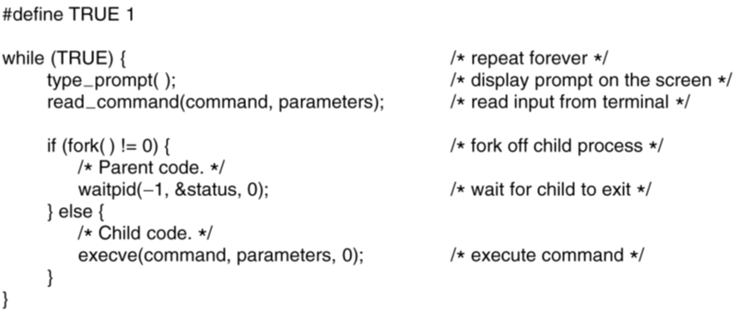
- Process Segments :
  - Text : Program Code(fixed , image)
  - Data : variables used , grows up
  - Stack : for procedure calls , grows down

- OS structure
  - Monolithic
    - OS is written as a set of procedures , all can call each other , compiled and linked into one large executable
    - A main program that invokes the requested service procedure.
    - A set of service procedures that carry out the system calls.
    - A set of utility procedures that help the service procedures.
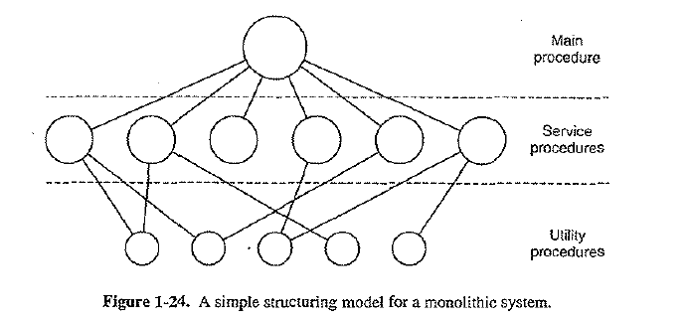

  - Layered
    - Each layer is built on top another one , abstracting the details
    - Could also be a concentric rings
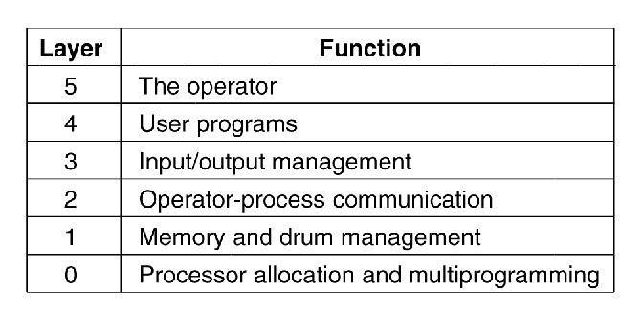
- Microkernel
  - Probelm is solves : if all modules ( device drivers), in one kernel and one has a bug , the whole system will break
  - Idea is to split os into multiple small modules and run them in user space , only one module (the Microkernel) is running in kernel mode , thus more reliability
  - Outside the kernel layer it has drivers , servers (File system , process manager ,..)
  - Reincarnation server , checks if other servers fails and reloads it automatically , more reliability
  - Mechanism not policy :Kernel defines mechanism like schedule the highest priority process , but let’s the server (user space ) to assign and determine a process priority (Policy )
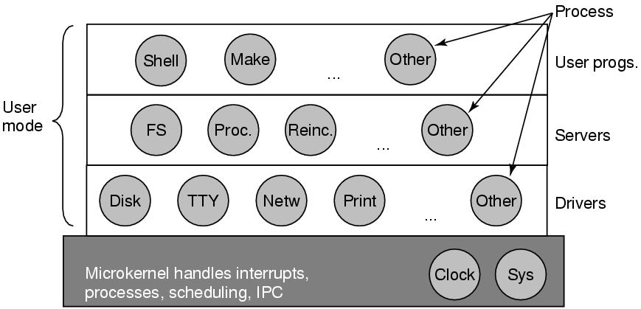

- Client server Model:
  - Like microkernel in separating modules , but classifies into client and server modules
  - Communicate via message passing
  - Modules can even be in different machines via a network
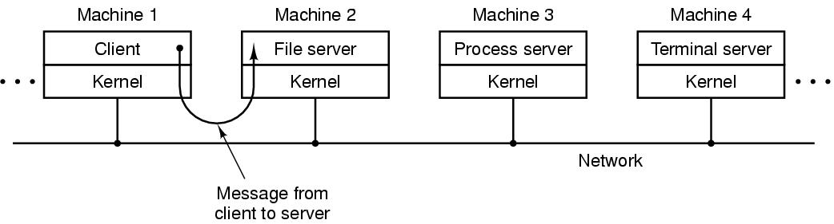
- Virtual machine :
  - Original Idea : A virtual machine monitor run over the bare metal and handling multiprogramming , it provides multiple virtual machines for layers above , unlike normal os as an extended machine (HW abstraction ), these virtual machines provides the same interface of the bare metal , thus can run different OS’s
  - When guest OS(CMS) app makes a system call , it’s trapped by it own VM(CMS) , then it call the host os (VM370), as it simulates under the hood multithreading and actual hardware
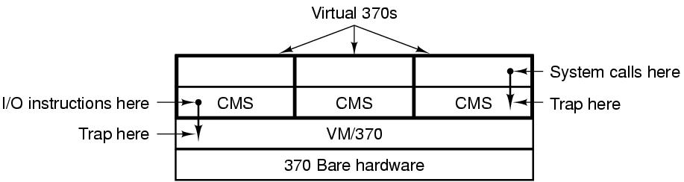
  - Modern Virtualization(PC)
    - Running multiple servers each with it’s own OS at the same time ( mailserver , web server )
    - In Web hosting , shared hosting and dedicated machines can be VM
    - PC users running 2 operating systems each one has his favorite apps
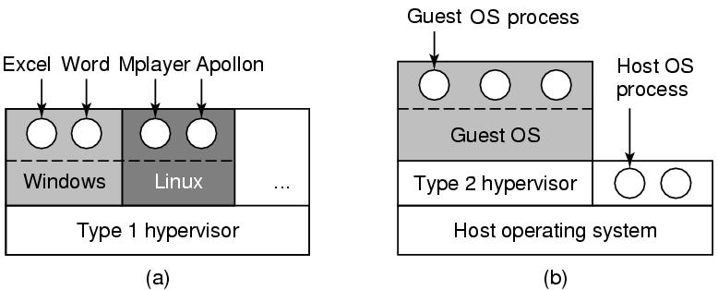
    - Hypervisor Type 1 is the old virtual machine monitor , runs on the bare metal
    - A problem in hardware as certain instructions are not allowed in user mode
    - Type 2 hypervisor (modern) solves the problem of enabling guest operating systems that run on top of host OS
    - Java virtual machine is another example , thus write once run every where
- ExoKernels
  - It’s not cloning the whole machine like VM but it partitions resources instead , each VM will get certain share of resources and it’s free to install different OS
  - The Exokernel sets at the lowest level to ensure each VM is getting it’s share
  - Advantage : removes one layer of mapping (each VM runs on the bare metal ) , exokernel needs only to know which machine is assigned to which resource

  - World according to C
    - Code (.c) , headers (.h), compile and link
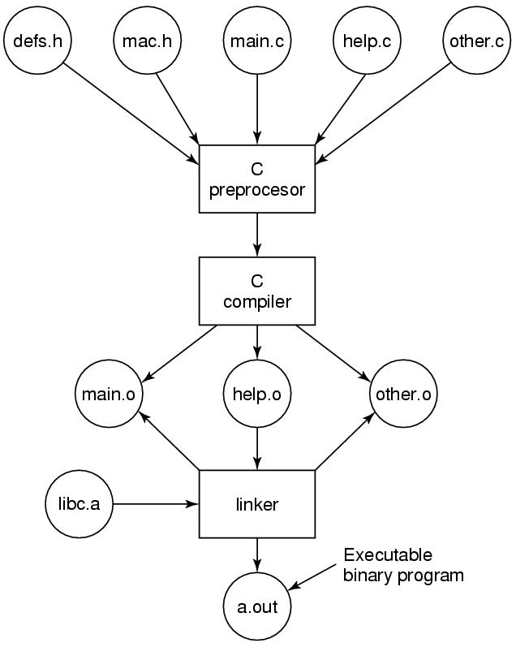

Chapter 2 processes and threads
- Process : an instance of an executing program, including program counter , registers values, variables
- Multiprogramming : is the rapid switch between multiple process at the same CPU , only one process is active at a time , vs multiprocessing where we have multiple CPUs
- Process vs program : program is a recipe while a process is active activity performing this recipe
- Events creating a new process
- System initialization.
- Execution of a process creation system call by a running process.
- A user request to create a new process.
- Initiation of a batch job.
- In linux all creation is done via fork (create clone image of parent), then execve for a child image
- Process termination
  - Normal exit (voluntary).
  - Error exit (voluntary).
  - Fatal error (involuntary). Due to bug
  - Killed by another process (involuntary).
- Process forks crate hierarchies from a single root , forming process groups , e.x init process in Unix
- Process states
  - Running(already executing now on CPU)
  - Blocked(unable to run until certain event happens like I/O)
  - Ready(runnable but waiting for other process run)
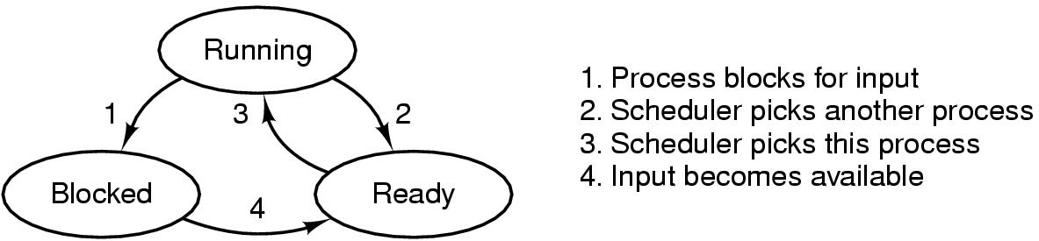
- Process table holds information about processes ,one entry per process
- Process entry has state , program counter , stack pointer , memory allocation ,open files , scheduling info . it could be classified into process management ,memory management, file management
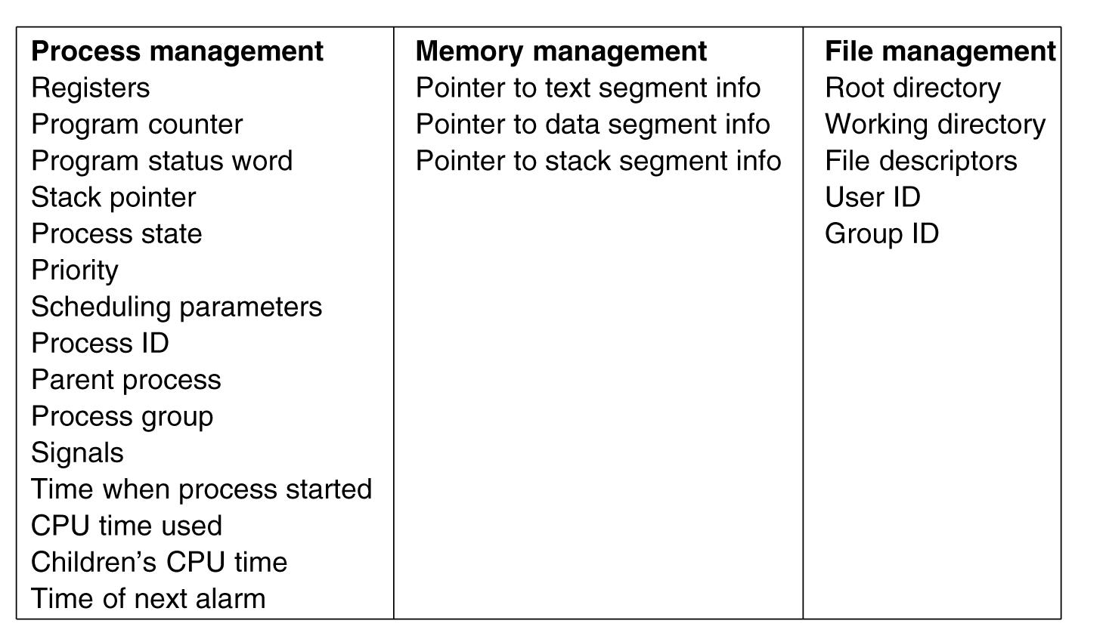
- At each I/O class there is an address to interrupt vector , it holds address for interrupt service procedure
- 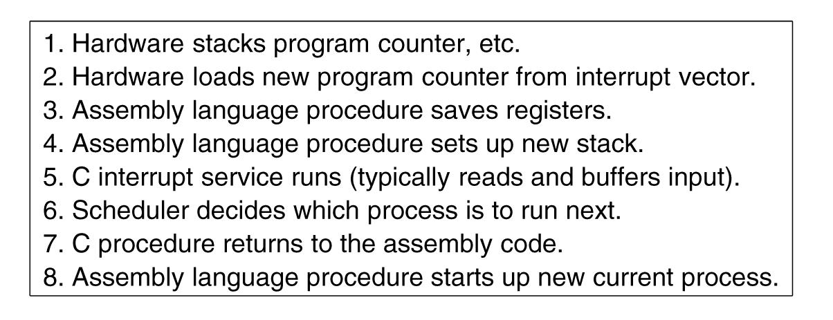
- Modeling multiprogramming , p is fraction waiting for I/O , n number of processes, CPU utilization =1-p^n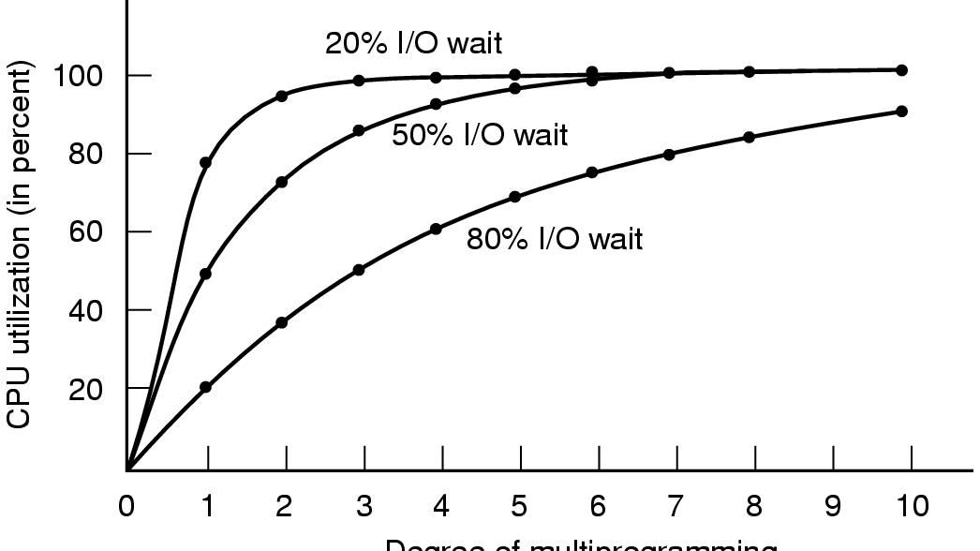 for 80% wait we can achieve high utilization by running 10 processes(more memory added can improve utilization)
- Threads : multiple threads of control share address space within a process ( which could be one thread )
- Threads Advantage
  - Simpler Programming model for process with multiple activates running in parallel where some could block
  - Lighter weight than process ,easier to create and destroy
  - Performance gain when some threads block while other CPU bound , activities could overlap
  - Useful for systems with multiple CPU , real parallelism could happen
- Thread examples : word processor , a dispatcher in we server creates worker threads for each request
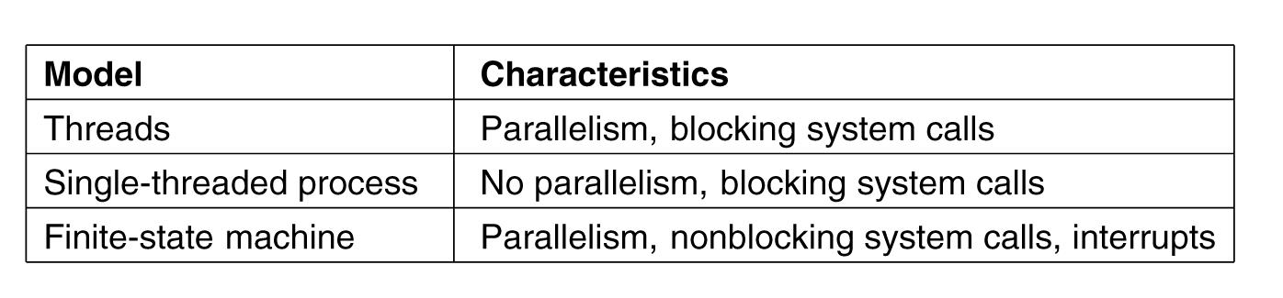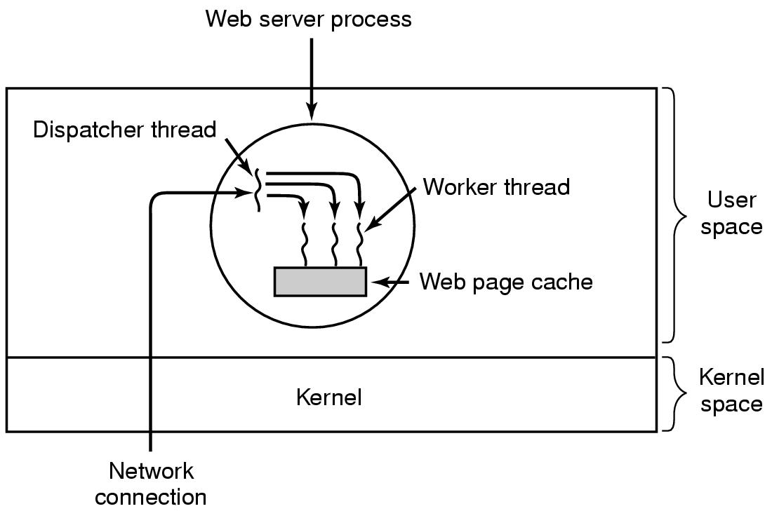
- Process groups resources together .threads defines units of execution (program counter, stack,..). Threads share address space and resources .multiple threads could run in parallel in a process (multithreading)
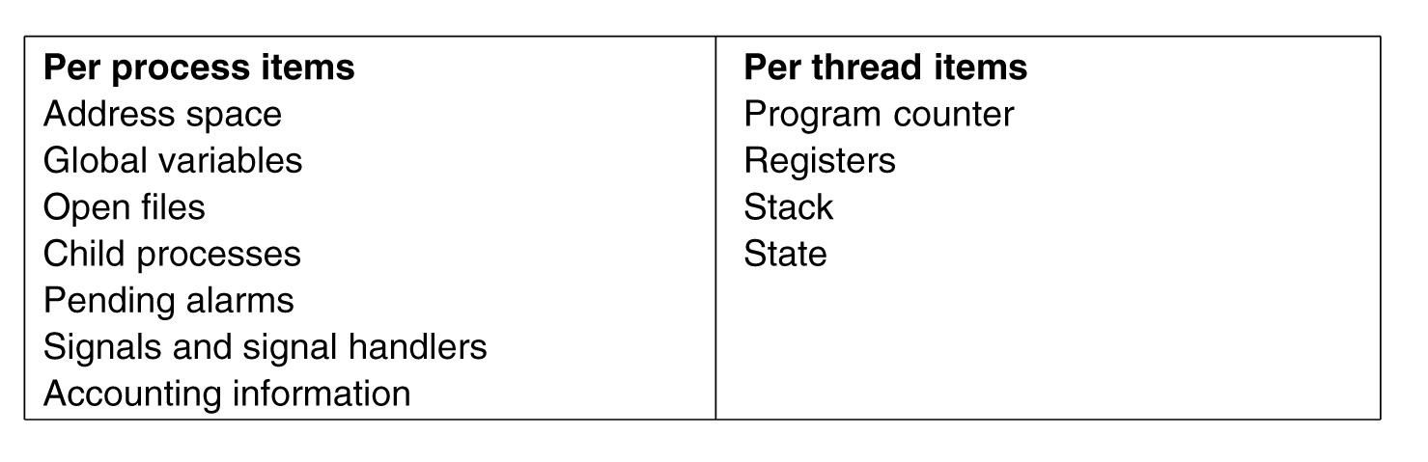
- Threads also could be in running, blocked , ready status
- Threads disadvantages :
  - More complication, when calling process fork does it fork all child threads as well?
  - If parent thread was blocked does the child block too?
  - If thread closes a resources(file) used by other thread
- POSIX pthread methods : create , exit, join( wait for other to exit), yield(release CPU for other threads)
- Thread implementation : User space , Kernel space , hybrid
  - User Space threads
    - Threads is implemented as a library running in user space , kernel knows nothing and it handles as a one thread process
    - Each process has its own thread table ( similar to what kernel does with processes)
    - Advantages:
      - User level threads could be implemented on OS that doesn’t support threads
      - Thread switching is a local procedure thus faster compared to trapping kernel , no need for context switch , memory is the same and caches are not flushed
      - Allows each process to have its own customized scheduling algorithm
      - They scale better , compared to kernels which might have a problem storing thread tables for large number of threads
    - Disadvantages:
      - Blocking system calls , thread can’t do system calls as this will trap OS and all other threads will be stopped ,violating the goal of multithreading
      - Could be handled by non blocking system calls , still a problem and need OS changes
      - Another option is to use a wrapped code , perform blocking system call only if after check , like read will only be called if there is a data , require rewriting system calls (BAD)
      - If a thread causes page fault , kernel don’t know and will block the whole process to fetch page , other runnable threads will be blocked too
      - If a threads started running , no other thread could run unless it voluntarily leaves CPU , in one process no clock interrupts so scheduler has no way to stop a thread
      - Making a process calls for clock interrupts has more problems and conflicts with OS
      - Problem in most apps the need for blocking system calls often , thus all process blocks
  - Kernel Level threads
    - No runtime needed, Kernel keeps track and holds a thread table for all threads in system(in kernel space or OS runtime), and beside also a process table
    - When a thread wants to create/destroy a thread , a kernel call handles that
    - Advantages:
      - When a thread blocks , kernel could run another thread or a thread from different process
      - No need for extra non blocking system calls
      - If a thread causes page fault , kernel check to see if any other thread in same process could be executed in the mean time
    - Disadvantages:
      - Creating/destroying threads in kernel are more expensive ,to solve this , thread recycling by marking thread as not runnable and recycle its data structures when needed
      - Buggy terminal thread could crash the system
      - Problem with forking , does it create child threads too
      - Signals ( sent to process not threads ) , which thread will should handle it , they could register to handle but what if more than one registered
  - Hybrid ( one kernel thread is multiplexed into multiple user level thread), programmer decides , more flexible
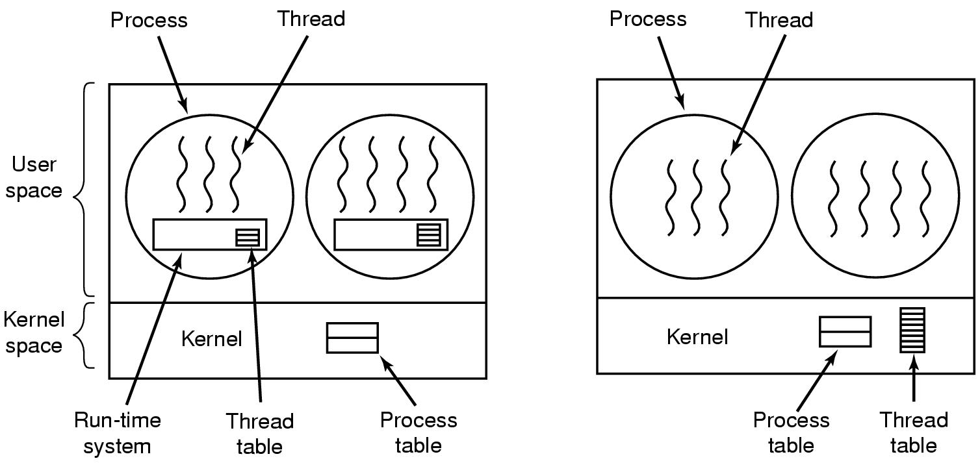
- Scheduler activations : hybrid solution, main goal is to allow a thread to call normal blocking system calls ,and if a thread blocks ,runtime(user thread library) can schedule another thread without transition to kernel space
  - Kernel assigns number of virtual processors to a process and let run time assign threads to processors
  - When kernel knows about a blocking (I/O , page fault) , it notifies the run time via upcall, run time schedule marks thread as blocked and run another one , later another upcall to mark it as ready
  - If HW interrupt came while thread is running , it switches to kernel , if a process needs it (page fault) , kernel notifies runtime
  - Disadvantage : upcalls violating the layer principles ( OS calling run time )
- Popup threads : each request is handled by crating fresh identical new thread (fast), advantage : latency or the time between message arrival and processing becomes so short
- Multithreading problems:
  - Accessing global variables by many threads
  - Library procedures are not reentrant : allows other thread call while current is not finished
  - Signals : which thread receives it
  - Stack management : when a stack over flows , how OS determine which thread stack to increase
- Inter process communication (IPC)
  - Race condition : where multiple processes are reading/writing to a shared memory , and the result depends on the order of who runs when
  - Mutual exclusion : only one process have access to shared variable , the other one is not (excluded)
  - Critical region: part of process where it access shared variables that might lead to a race condition
  - Conditions required to avoid race condition
    - No two processes may be simultaneously inside their critical regions.
    - No assumptions may be made about speeds or the number of CPUs.
    - No process running outside its critical region may block other processes.
    - No process should have to wait forever to enter its critical region.
- Mutual exclusion by busy waiting
  - Disabling interrupts
    - By disabling interrupts (clock interrupt) , process switching won’t happen , so a process disables interrupts and enter critical region , then enable when it’s done with critical region
    - OS can disable interrupts for its need , but user mode are not supposed to do it
    - Problems :
      - Unsafe to allow a process(user space) to disable interrupts , what if it fails or didn’t enable interrupts again
      - If system has many CPUs disabling interrupts will only work for one CPU
  - Lock variable
    - Set a single shared variable(lock) to 1 and enter critical region , else wait for it to become 0
    - Fatal problem : process A could read first (0) then switches , process B reads(0) set it (1) , enters B critical region , now A switches back and set it (1) too and run critical region too
  - Strict alternation
    - Process o loops waiting for turn to be 0 else wait , process 1 loops for turn till it’s 1, else wait
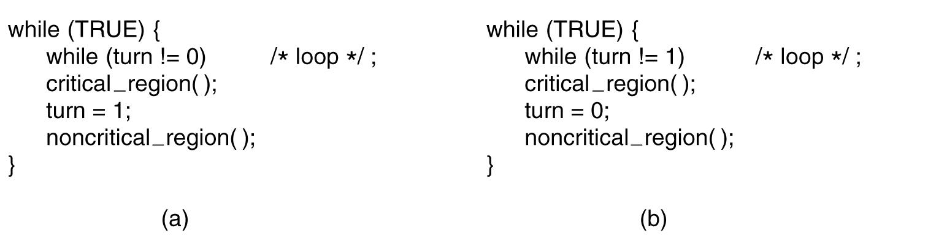
- Busy waiting wastes CPU , if lock is busy waiting it’s called spin lock
- Problem: when one process is too fast than the other it might get blocked waiting for turn flag while the other one takes time inside it’s non critical region, it violates role 3 (No process running outside its critical region may block other processes).
- Peterson’s solution : interested and turn flags
  - If 2 process at same time setting turn , the last one is the one it counts
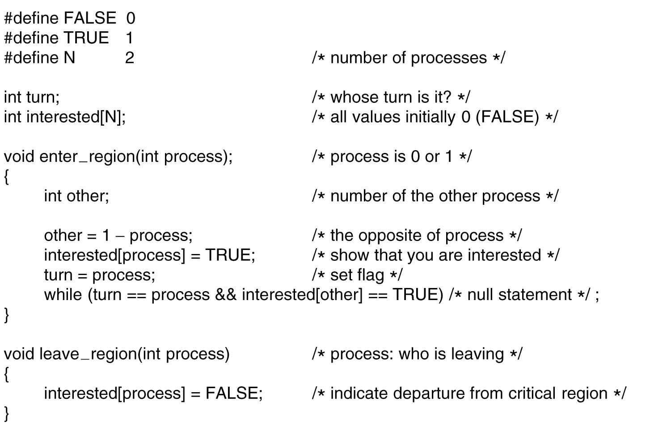
- TSL instruction : an atomic instruction at HW level TSL ( test , and set lock)
  - TSL REGISTER,lock : reads lock into register , set lock to non zero ( atomic )
  - CPU does locks memory bus preventing any other process(or CPUs) to access shared memory, vs disable interrupts which works only for one CPU
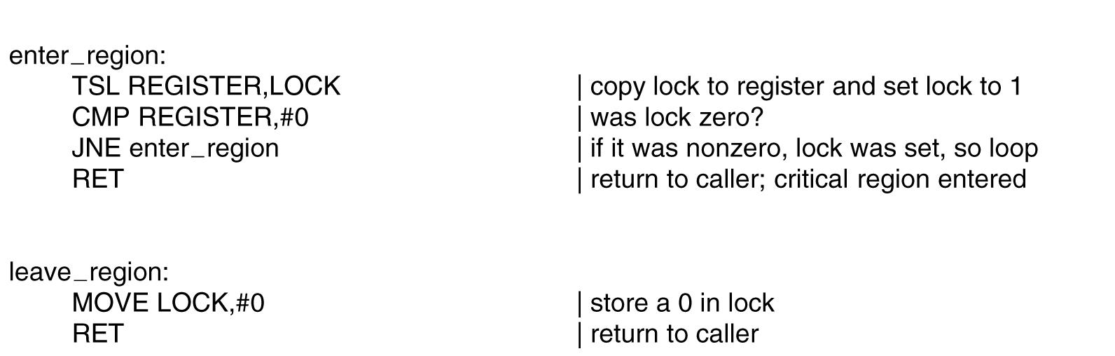
- XCHG , similar to TSL , swaps 2 values atomic
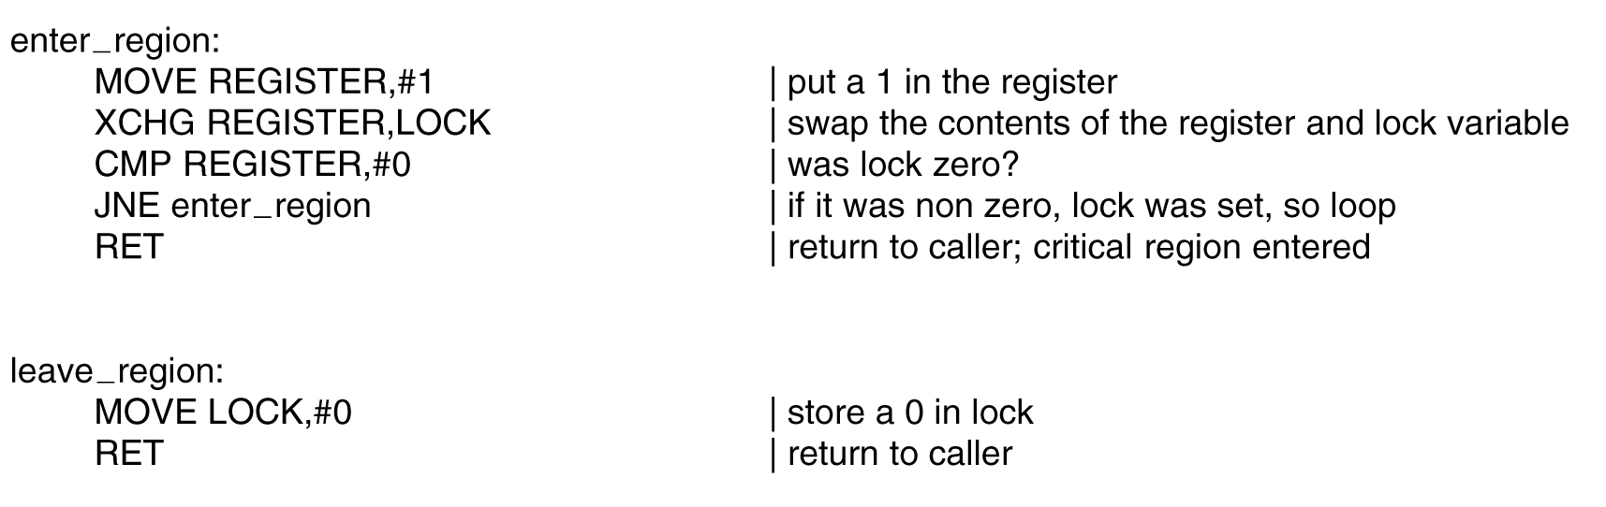
- Sleep and wakeup (Via Blocking , no busy waiting any more )
  - Priority inversion problem : a high priority process H runs whenever it’s ready over a low priority L , no if L is in critical region , H will busy wait forever as L is not allowed to be scheduled over H
  - Sleeps make a process block , it’s then awakened by another process via wakeup ( takes process #)
  - Producer consumer problem :
    - Accessing shared count without protection leads to a race condition. if consumer read value of count =0 and before it sleeps it was switched , producer out element , increment count , now count ==1 so it send wakeup to ( non sleeping yet process), so signal is lost , now consumer is switched back and it goes to sleep, eventually producer will fill buffer and both are sleeping now
      - Adding wakeup waiting bit could solve it for simple cases , the more process the more bits needed (not a solution)
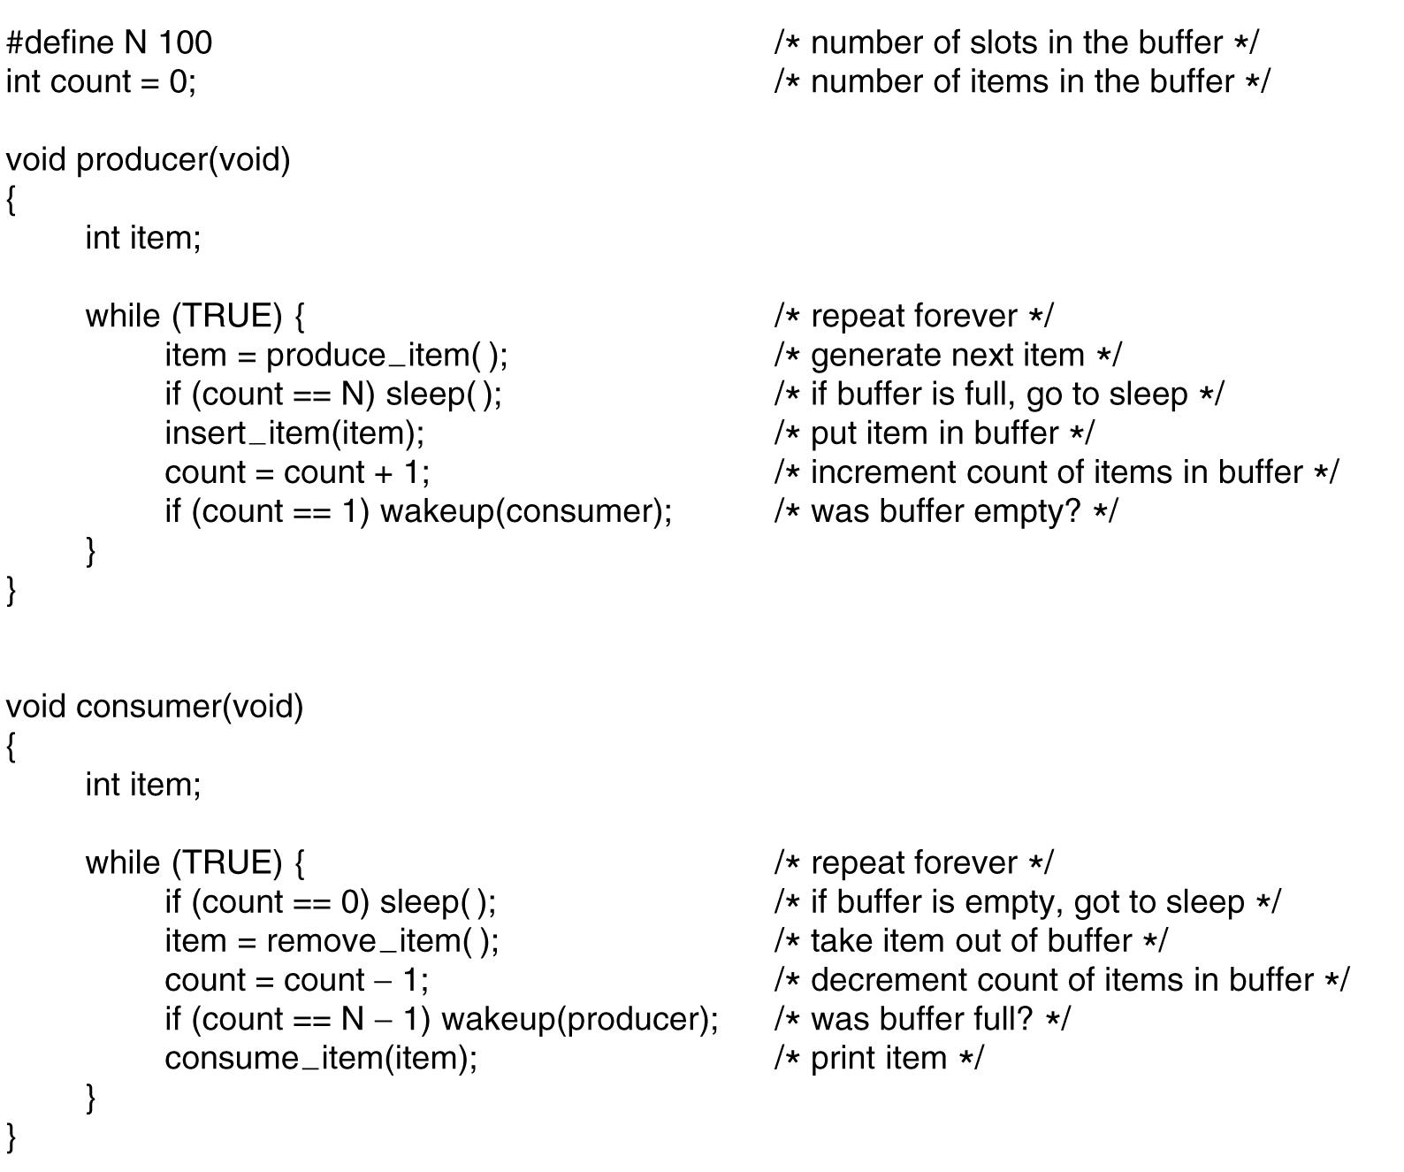
- Semaphores: integer variable used to count number of wakeups for future use , non zero if wakeups are pending , zero no wakeups . It solved the lost wakeup problem above , it also hold list of sleeping processes
  - Down/up are generalizations to sleep/wakeup. Atomic operations (spin locks inside)
  - Down check if value is non-zero, if so it decrements and continue, else it sleep (block) and don’t continue its operation.
  - Up increments the semaphore count, if there was one or more process sleeping before, one is selected by OS and allowed to continue its down operation processing.
  - In Up operation if there was one process sleeping , after calling up value will still be zero but one less process is waiting now
  - Initial value of semaphore count determine number of process could run without blocking , when initialized as 1 => mutex ( run one process then block and wait for up signal) (Binary semaphore)
  - 2 uses of semaphore :
    - Mutex : if value =1 , only one process is running at a time
    - Synchronization : guarantees order of events sequence ( processes order )
  - Solving producer consumer using semaphores
    - A semaphore atomic operations is done by system ( TSL , spin locks ), it’s ok to use busy waiting to implement semaphore primitives, but using semaphore itself ( blocking method) to deal with producer consumer ( P/C ) as P/C takes longer time
    - 3 semaphores:
      - Full : count number of full slots , init value 0 , synchronization
      - Empty: count number of empty slots : init value=n , synchronization
      - Mutex : used to protect shared buffer : init value=1 , mutex
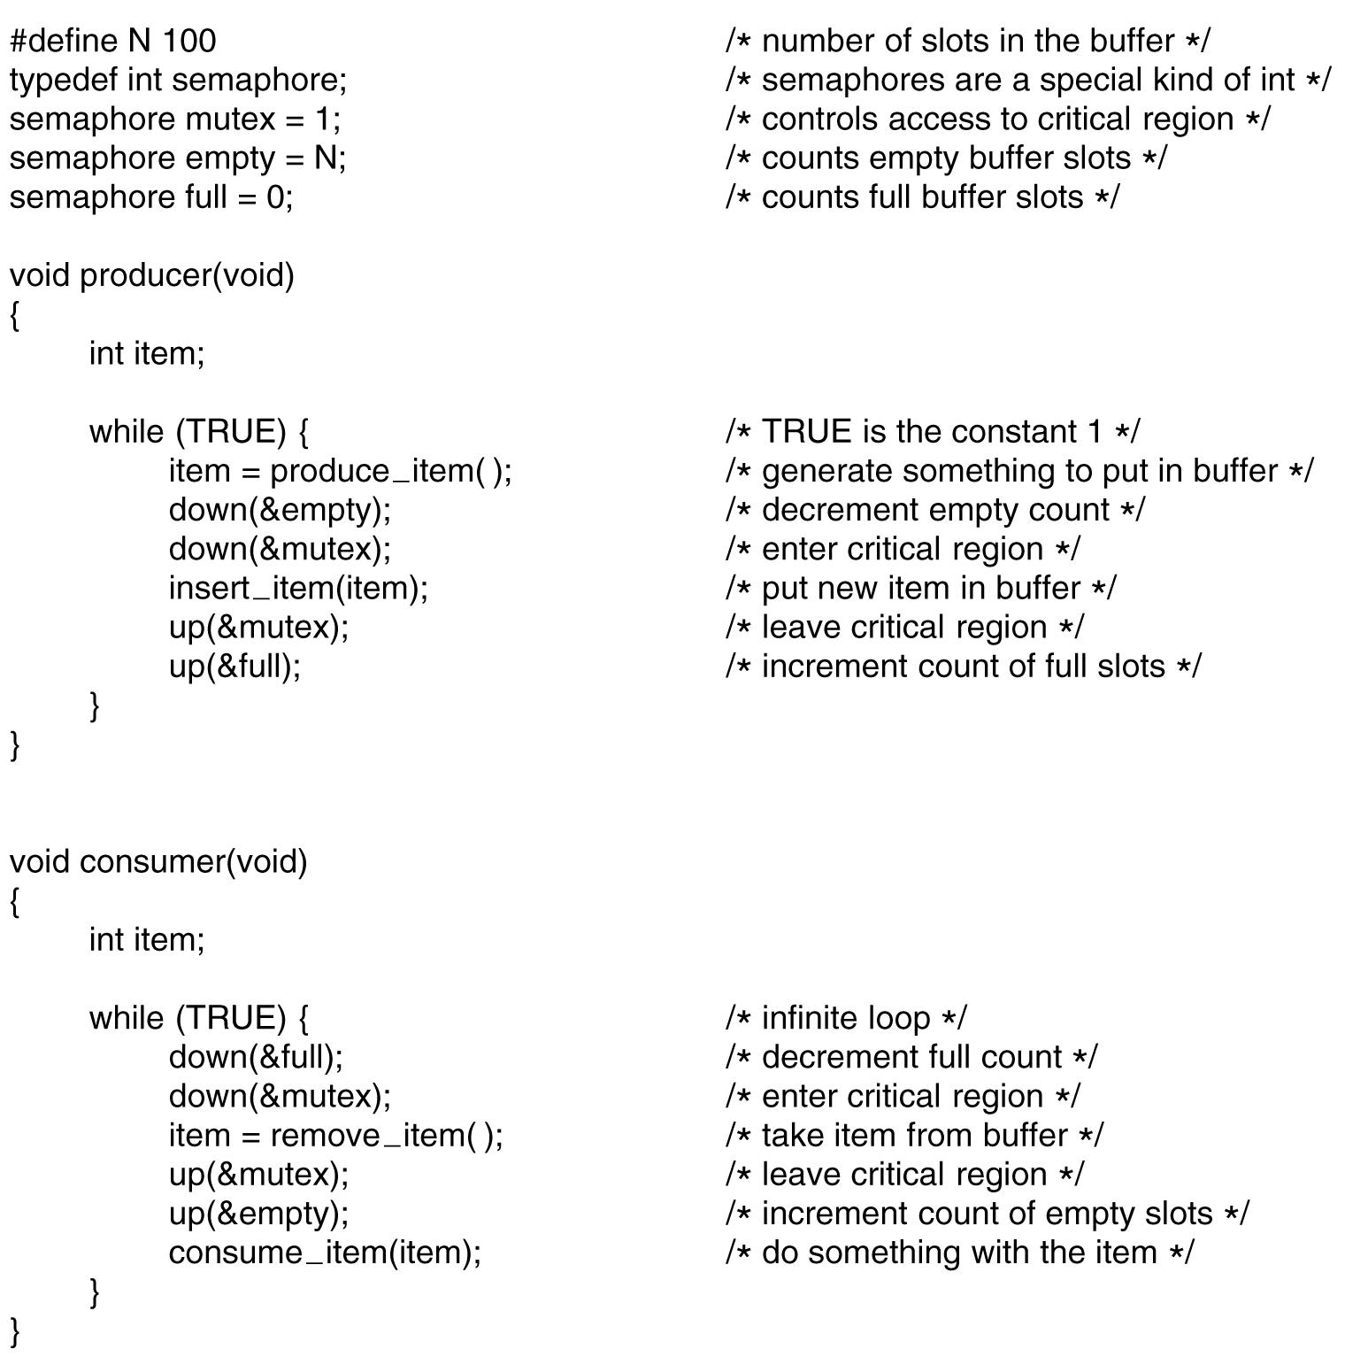
      - Mutex : simplified semaphore without the counting abilities , just 1 or 0
        - It’s so simple so it could be implemented by TSL , the main difference between it and lock( enter region) , is spin lock is using busy waiting loop , but here it calls thread yield (block ), calling yield is a user mode call thus thread library (user Mode ) could do mutex very fast , no need for kernel
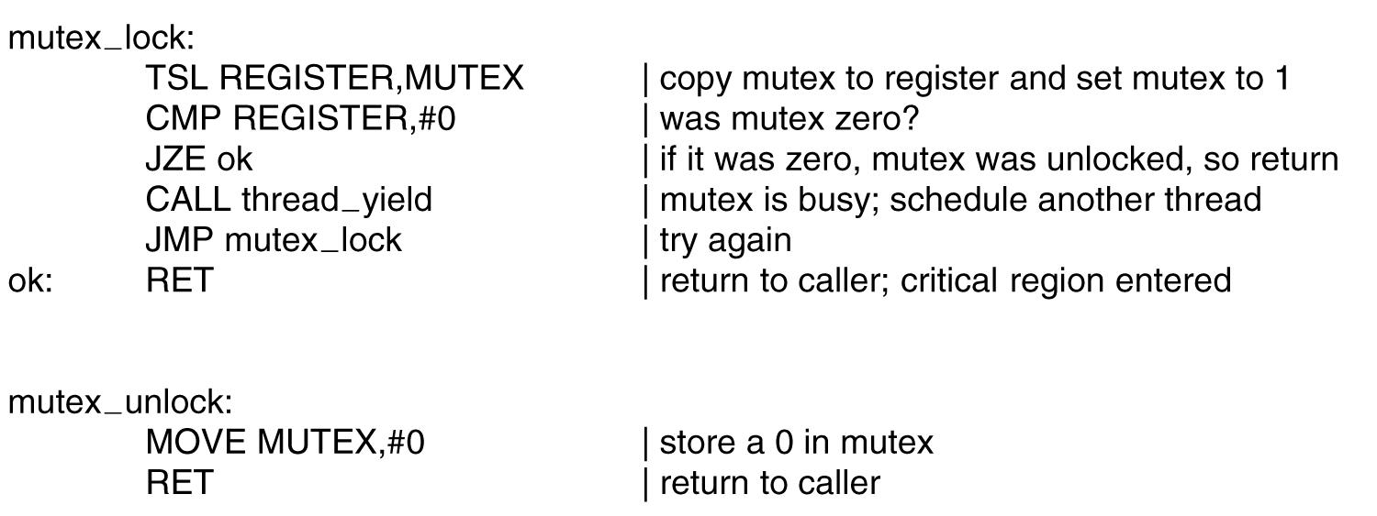
- IPC between different process : problem in algorithms above a shared (spin lock or mutex) is accessible from process address space , but multiple processes has disjoint address spaces , how they can access it too ?
  - Kernel could provide a way to share semaphores between threads and use it via system calls , else a file could be used
- Pthreads mutexes : create /destroy , lock : tries to acuire lock else block , tryLock : try get lock else do something
- Pthread condition variable : block if condition is not met ,have no memory , vs mutex to control critical regions
  - Mutex and cond-variable are used together : one thread lock a mutex then wait for condition variable ( met by another thread )
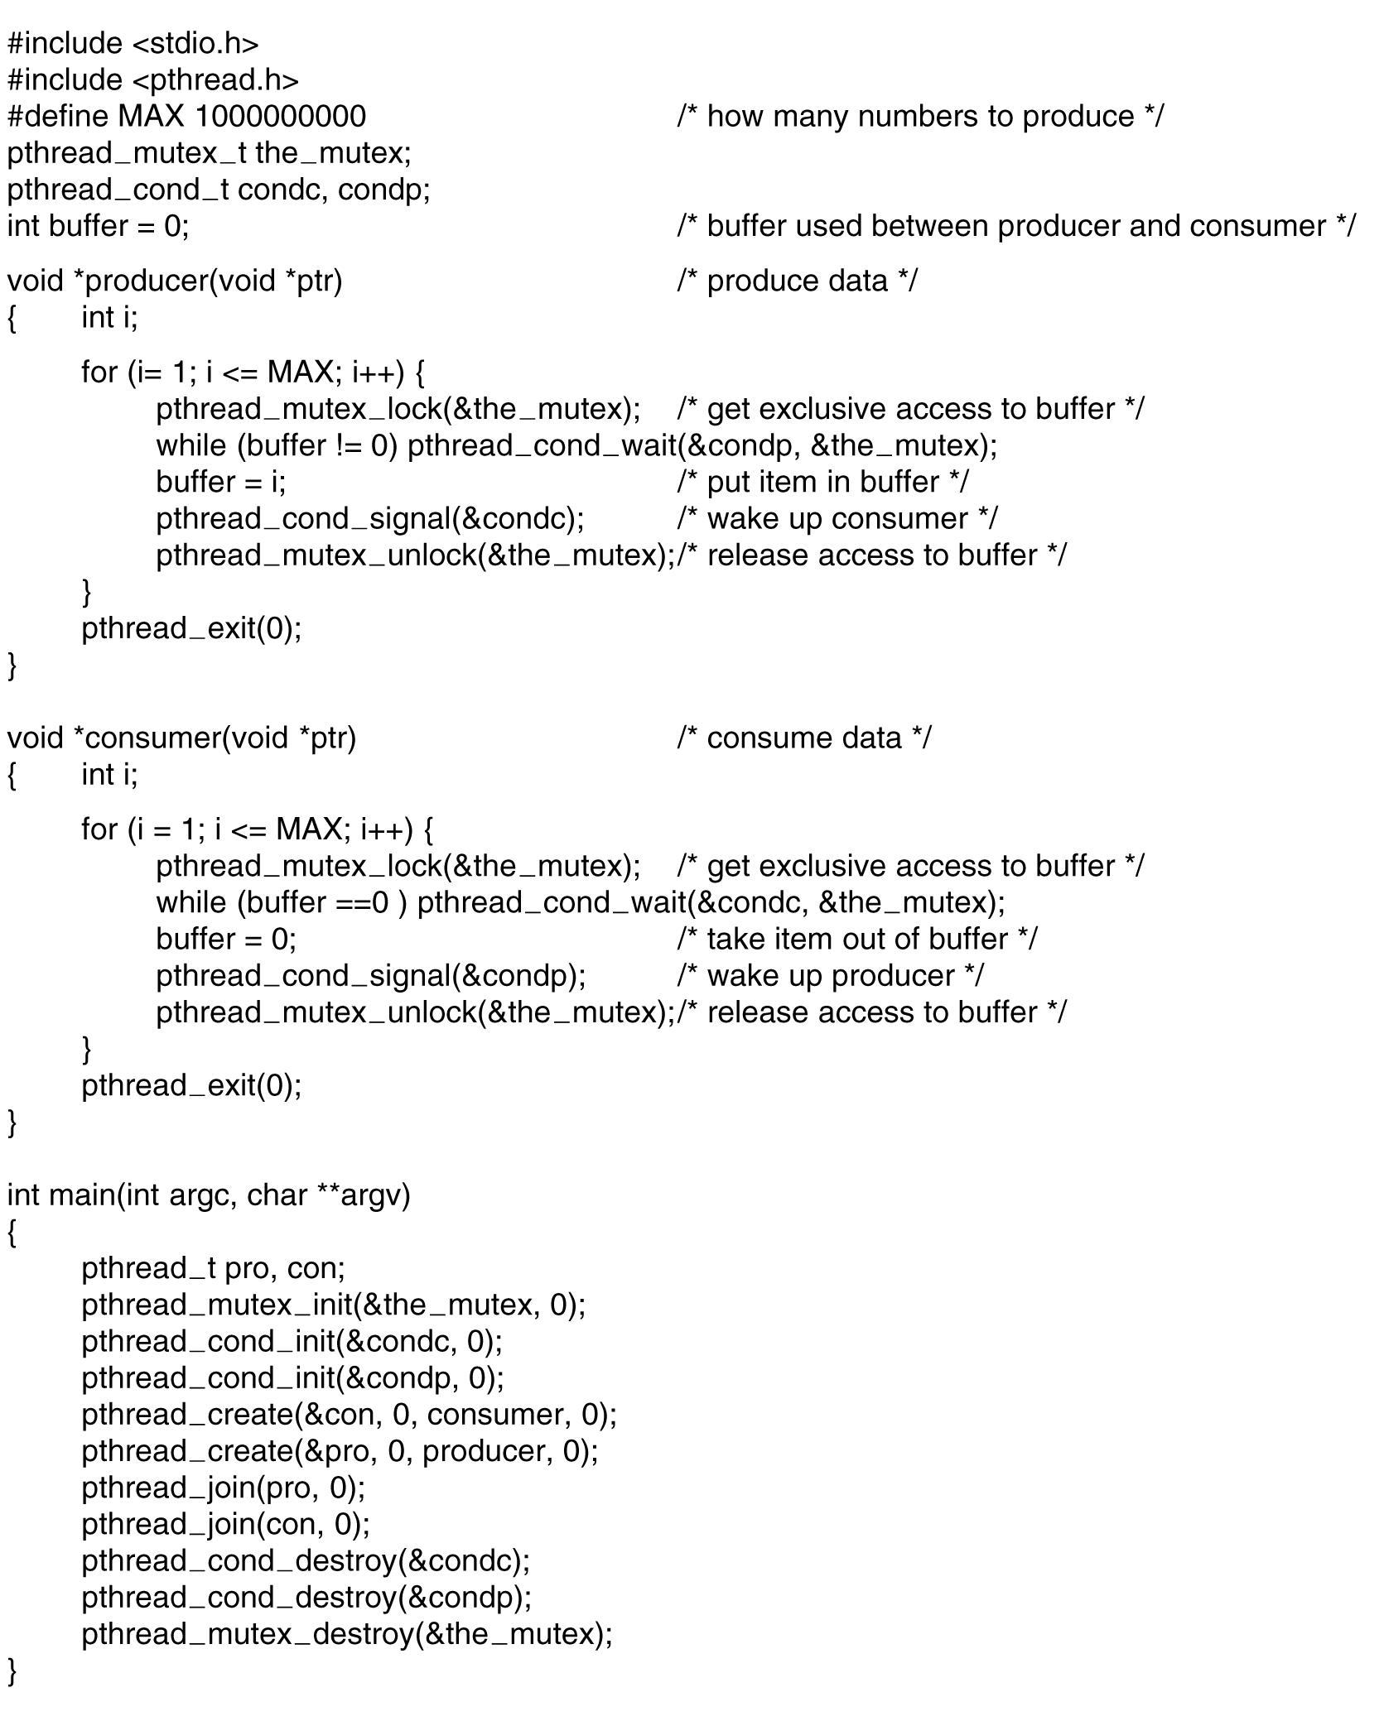
- Monitors : problem with semaphore/mutex is programmer has to write order of downs/ups correctly , if a bug a deadlock could happen ( programming in semaphores is like programming in assembly )
  - Monitors are high-level synchronization structure , it’s collection of procedures ,data structures, internal
  - Only one process can be active in a monitor at any given time , compiler will handle these monitor calls , it’ll check if there is another process in the monitor the calling process will be suspended
  - Compiler will implement the monitor programming construct by semaphores or mutexes ( no human , no errors)
  - Programmers put their critical region code inside a monitor procedure , plus condition variables to block too, thus allows other process to enter into monitor
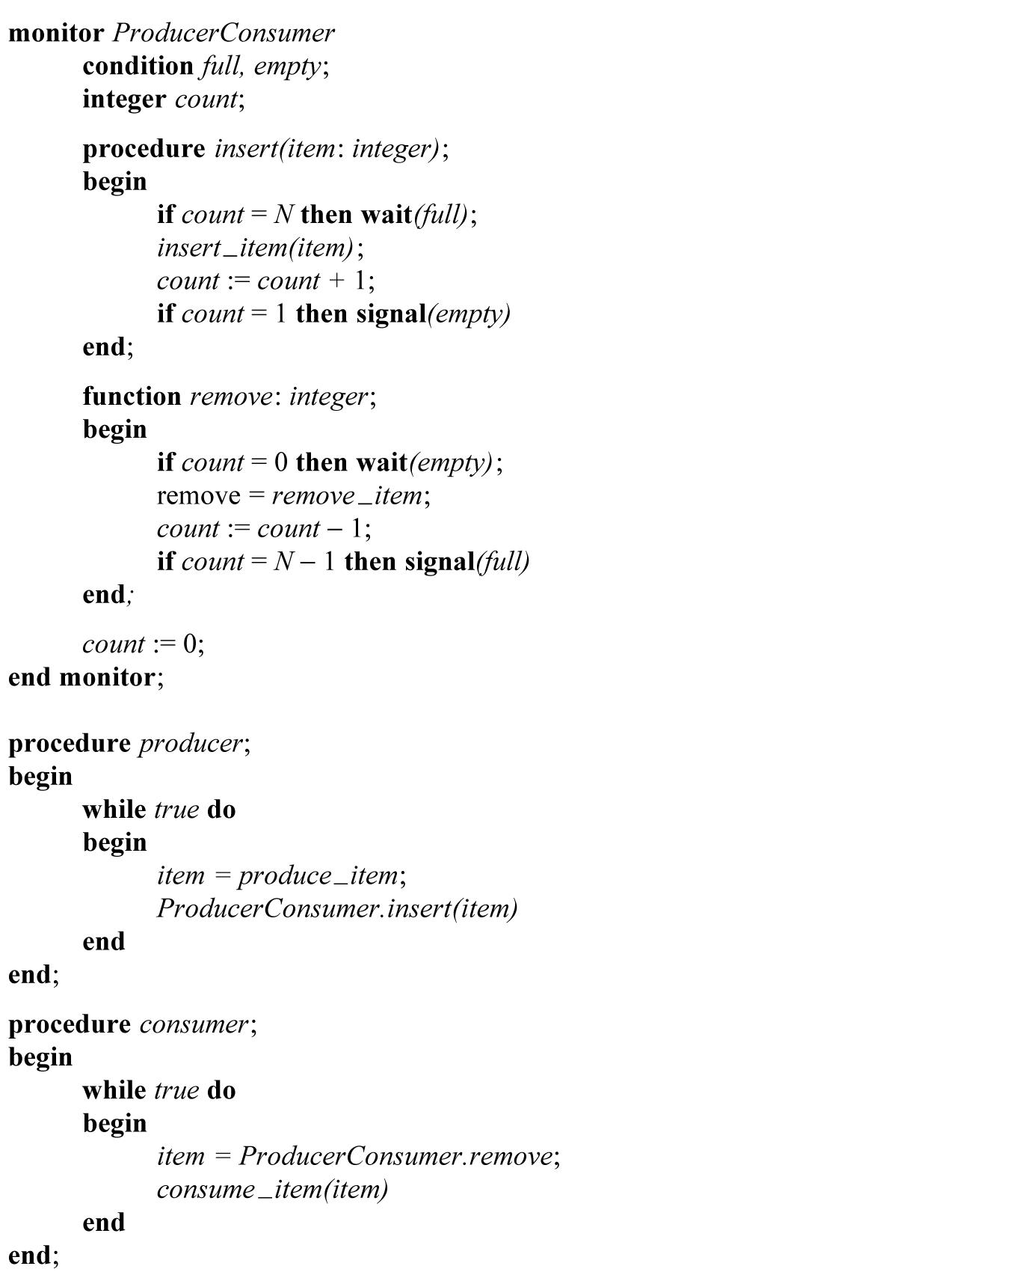
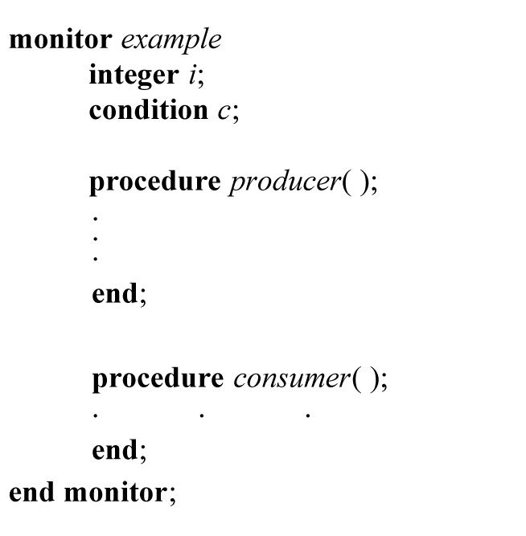
  - Monitor will ensure mutex , no other process is allowed to execute
  - Java synchronized keyword is a monitor , but Java has no condition variables instead uses wait and notify
  - Probems :
- programming language support needed (compiler)
- Monitors and semaphores can’t be used in distributed systems , as they use Local shared memory , message mpassing is needed
- Message passing
  - Use send/Receive which are system calls not language constructs(vs monitor)
  - If no message the receiver will be blocked until a message arrive
  - Problems:
    - If using network to send message , message could be lost , solution : use ACK acknowledgments
    - Use sequence numbers ( sender when time out with no ack will retransmit , ack could be lost ), so receiver will use sequence to tell if this message was received before
    - Authentication is needed to define a process
    - Producer consumer via messages
      - Producer blocks for receiver to send empty (has empty slots) message (on receive call)
      - Consumer blocks for sender message of item ( receive call)
      - Mailboxes ( bufferes )are used to store incoming messages
      - Rendezvous : when no buffers used sender will send and block , and receiver will receive and block ( just one message)
- Barriers : Used between group of processes instead of 2 , when multiple processes can’t go to next phase until of them reach to a certain step ,a barrier is implemented so all process will be suspended until last one arrives .

- Scheduling
  - Scheduler chooses I/O bound process to run to keep disk busy ( takes time ), context switching is costly too
  - When to schedule :
    - A process creates a child , which one to run parent or child
    - When a process exits , other process will be selected or an idle process
    - If a process A is blocked in critical region for semaphore signaled in process B , B should be selected to allow A to continue , but scheduler has no way to tell this depency
    - When I/O interrupts for finished reading , one process that was blocked is ready now , so scheduler has to decide to run it or continue the current one
    - If HW clock interrupts , scheduler can run on each clock or k-th clock tick
- Nonpreemptive scheduler: if a process starts it’ll take all the time until it exits or let the CPU for others
- Preemptive scheduler : uses clock interrupts to suspend a process if it’s still running after some time and picks another one to run
- Scheduling algorithms :
  - Batch:non preemptive or long time period emptive are fine
  - Interactive: preemptive is needed for god response , general purpose with many apps
  - real time: non preemptive may not be needed as process has defined deadline . it has special apps that follow deadlines vs interactive where general apps compete for resources
- Scheduling goals
- 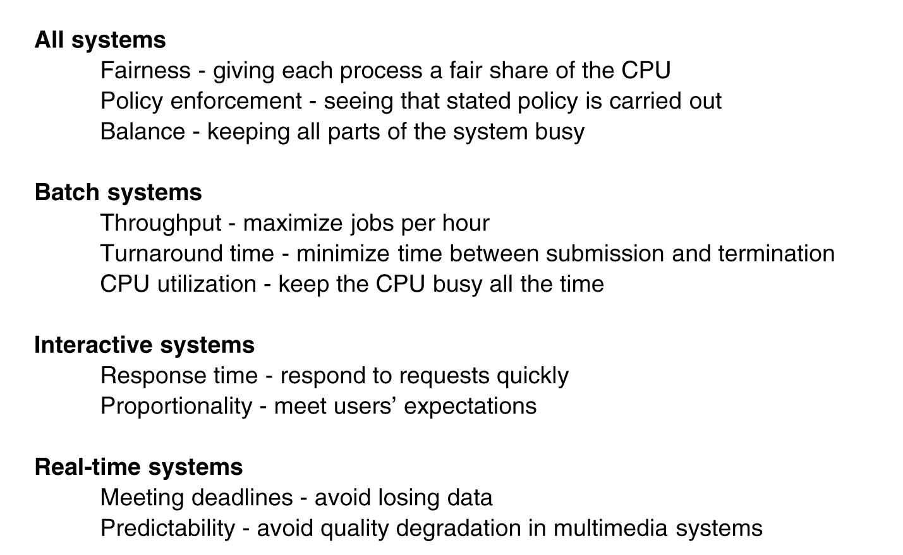

- Throughput : number of process / hr
- Turnaround time : time it between job arrival and completion
- Scheduling algorithms : Batch systems
  - First come first served (FIFO queue)
    - Non preemptive , easy to implement
    - Probem if compute bound run 1 sec , followed by I/O bound with 1000 , they had to wait for 1 second to perform , thus taking too much time , better approach is to schedule them during the 1 second process
  - Shortest job first ( non preemptive):
    - A(8),b(4),c(4),d(4) , will be scheduled as B(4),c(4),d(4),A(8)
    - Mean Turnaround time before 8 +12+16+20 / 4 ( # of process)
    - Mean turnaround time after = 4+8+12+20/ 4
    - It’s only optimal if all process are ready and available at the beginning
  - Shortest remaining time ( preemptive)
    - Allows new short jobs to get serviced ( the remaining time is short )
- Scheduling in interactive systems
  - Round robin ( preemptive):, each process is given a quantum (time interval), it’s switched if it it’s still running after that time , or if it’s blocked before that time CPU switching occurs too
    - A trade off for quantum interval :
      - too short -> CPU is used for context switching lower utilization
      - too large -> slow poor response as last process in list has to wait more
  - priority scheduling : vs round robin that treats all process as equally important
    - each process is assigned a priority , the highest one is selected
    - To prevent a process from running forever CPU lowers its priority at clock tick , until it’s lower than another process then that process is switched
    - Priority assignemet could be staticly or dynamically ( e.g if I/O bound are given high priority as they will block soon , thus keep disk busy)
    - Priority=1/f ( f is the fraction of CPU used during last quantum ){f=50% ->p=2 , f=100% ->p= 100}
  - Group processes into classes, use priority scheduling between classes but round robin inside a class .e.g. finish running all process in priority level 4 ( round robin between these class ) , then run level 3
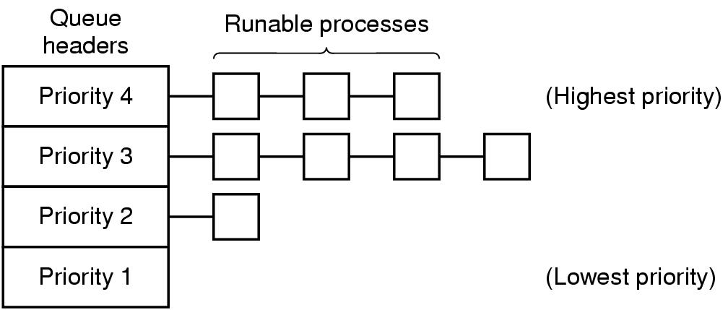
- Multiple queues
  - Problem when a process is CPU bound the time to perform context switch is costly , thus we should give it more larger quantum time to run , the problem is it makes poor performance , the multiple queries algorithm will assign 1 quantum for first level , 2 quantums for second , 4 , 8 and so on .. in the beginning a process is given 1 , if at the context switch time it’s still running , move it to a lower queue thus next time gets 2 , then 4 , and so on
  - Advantage , for a process needs 100 quantums it’ll get 7 context switches instead of 100
- Shortest process next ( works for interactive vs shortest first (batch) ):
  - Aging : Makes estimate of execution time = aT0+(1-a)T1 , usually a=0.5
- Guaranteed scheduling
  - If N users each one gets 1/N of CPU , ration could be 0.5 or 2.0 , scheduler will pick the lowest first
- Lottery scheduling
  - Give processes lottery tickets , pick at random the ticket owner wins , new processes could get ticket (fair) and be selected (responsive), more important get more than 1 ticket ( higher chance to be selected)
  - Processes may share tickets like clients give their tickets to server to make it selected next
- Fair share scheduling
  - Takes owner into account , if 2 users each get 50% of CPU , user 1(A,B,C,D0, user 2 (E) => A E B E C E D E , if user 2 has twice user 1 share of CPU => A B E C D E ,..

- Scheduling for real time systems
- Hard real time : all dead lines are meet , vs soft real time : some could be missed (media video/audio)
- Periodic events : they come at regular intervals
- Schedulable real time system has 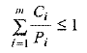, where m number or processes , process I comes at period p and takes time C on CPU
- Policy vs mechanism : mechanism at kernel to use priority , but let user space assign process priorities (policy)
- Thread scheduling:
  - User level threads ( no clock interrupts) , kernel know nothing about a process so it gives it quantum inside it user thread library will run A1 the whole tile or if it cooperates then A1A2A3 , then OS will switch to run process B
  - Kernel level threads : kenrel knows sbout threads and give each one ( even in different process quantums ) and does switching , thus A1 B1 A2 B2 could be valid sequence
  - Major difference :
    - user level threads has a better performance as no user/kernel mode switch
    - Kernel level thread when block doesn’t block the whole process vs user level threads
    - If two threads with same priority , one is from same process another is different , kernel thread will pick the one in the same process to save context switching
    - User level threads can have customized scheduler suited best to certain app needs, thus better tuning
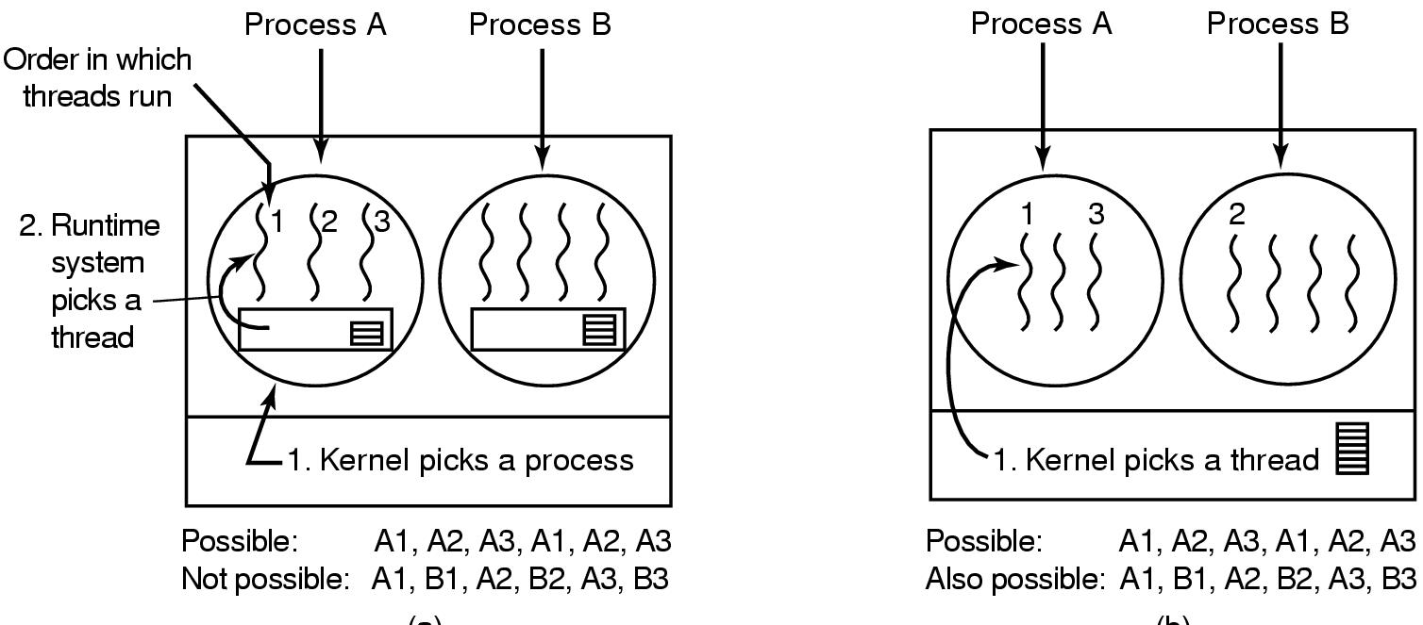
    - Classical IPC problems :
      - Dining philosophers
        - Models the case where multiple processes are competing for resources
        - Take left then wait for right fork => deadlock if all picked left and waiting for right
        - Take left if no right leave left fork => starvation as all can do the same , run indefinitely and do nothing (pick &leave)
        - Take left and wait for right for random time then leave left => depends on timing and not suitable for mission critical (bad luck in random time can also make starvation)
        - 1 semaphore per philosopher , 1 mutex for critical region , and check both left and right philosophers are not eating to allow 2 to eat
          - Figure 2-46 pg 97 (164)
- Readers/writers
  - Models access to database , multiple reads are ok , but one write should block all others until it finishes
  - First reader (down)db semaphore , next readers increment a counter ,when they leave they decrement the counter , the last reader will (up) db semaphore to allow a waiting writer to run
    - Problem :readers continue to run as long as there is at least 1 active reader and writer could wait forever
    - Solution: when a reader comes and a writer is already waiting , block the reader , thus writer only waits for readers who came before him . Problem : less concurrency and low performance
    - Figure 2-47 pg 98(166)

Chapter 3 Memory managemet
- Memory manager : keep track of memory allocation/deallocation to processes as they need
- No abstraction methods (only one app is running in memory):
  - A ,C if there is a bug in app , whole system will crash , b is used for handheld devices
  - 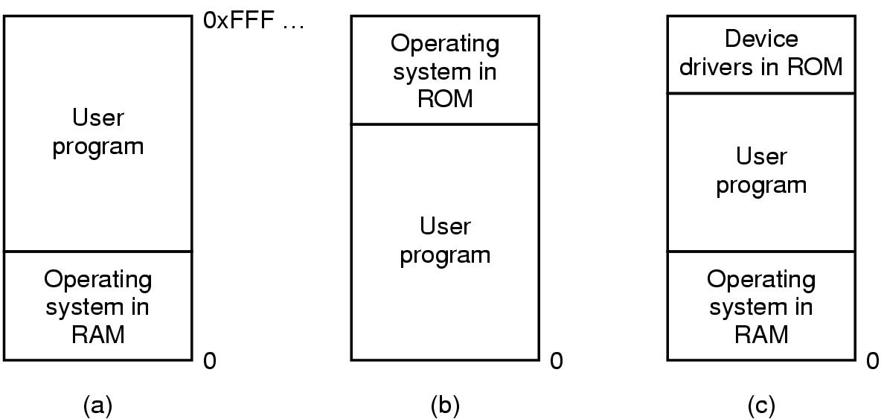
  - One solution is to divide memory, protect by PSW(programs status word ) , OS will check each read/write operation if it belongs to the right app => problem is absolute address (jmp 28) , fix : static relocation , by adding the base address where application is loaded in memory to all memory access instructions . static relocation problems : slows down system , need extra info tell whether a value in an instruction is memory address or not
  - Problems of direct physical memory addressing:
    - If user app can access all memory locations it could crash the system ( unless there is a HW protection locks)
    - Running multiple apps at once is not possible
    - To solve these relocation and protection problems has to be solved(via Address space )
  - Base & Limit registers : HW has 2 registers Base and limit , base is where application address is loaded in memory , limit is the length of the program . every time a process references memory :base is added to address , result address is checked to make sure it’s within limit value , else an error is generated
- Problem : additions at each memory reference is slow

- Swapping & virtual memory deals with memory over load ( need memory more than physical memory)
- Swapping : bringing each process entirely in memory , run it , then put it back on disk
- Virtual memory : allows programs to run even when they are only partially in memory
- Swapping creates hole/gaps in memory : fix via memory compaction : combining all used memories together(costly)
- 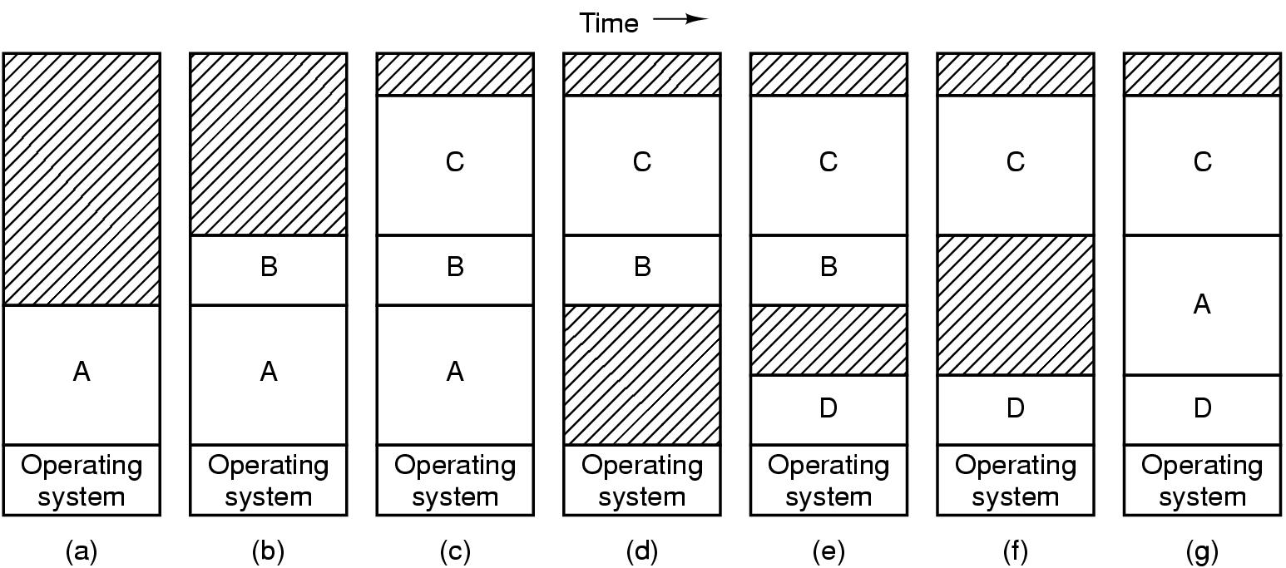
- Allocate memory so that stack segment goes down and data segment goes up ( as process needs extra space)
- The space between segments(stack,data) allocated to either , if no space then process will be moved to a hole with enough space , blocked until extra space found , or killed
- Memory management ( keeping track of used/free memory
  - Bitmap :memory is divided into allocation unit , each unit will be 1/0 in the bit map ( unit could be word – KB)
    - Smaller allocation unit -> larger bitmap , larger allocation unit : rest of unused unit is wasted
    - Pros : simple , bitmap is small and depends on memory size and allocation unit size
    - cons : searching for free memory( consecutive 0’s) is slow
- Linked List:each node is P(process)/H(hole , start address , length
  - If sorted by address , then swapping memory when process exits/swaps is fast
  - To make it easier to find neighbor(hole) , double linked list is used
  - Memory allocation algorithms:
    - First Fit : scan the list find the first hole big enough( fast, search as little as possible)
    - Next Fit : keeps track where it found last hole , it start search from this place ( not the beginning)
    - Best Fit : search all entries , select smallest hole just enough to hold the process (slower , more gaps)
    - Worst Fit : big the largest gap ( tries to minimize holes , still not good )
    - Quick fit : keeps lists of free holes of common sizes (4KB,8KB,..) (fast to locate hole big enough, like all others sorting by hole size , is when process exits/swaps it’s costly to merge holes together)
    - Virtual Memory : solved problem is application is larger than to fit into memory
      - Overlays: pieces of app that swapped in memory. problem : programmer had to divide app ( complex)
      - Virtual memory : each app has address space , divided into chunks (pages), pages map to physical memory , but not all of them has to be in memory at the execution time
      - If app references address in a page loaded in physical memory HW does mapping , else kernel fetch it and continue
      - Page : chuck of virtual address , page Frame : The corresponding page in physical memory
      - MMU (Memory management unit) : maps virtual address to physical address ,resides between CPU and memory bus
      - MMU keeps present/absent bit to tell if page is loaded in memory ( page frame ) or not
      - If page is absent , MMU detects that and traps OS ( Page Fault ) , OS will swap(write to disk) some page and replace it with the needed page frame, and continue
      - MMU Ex: 16-bit virtual address is divided to 4 bit ( page no)=> 16 pages , 12bit( offset inside page )=> page size =2^12
      - Page number is index into page table , if present then map to page frame(base from table)+offset , else trap os with page fault
      - 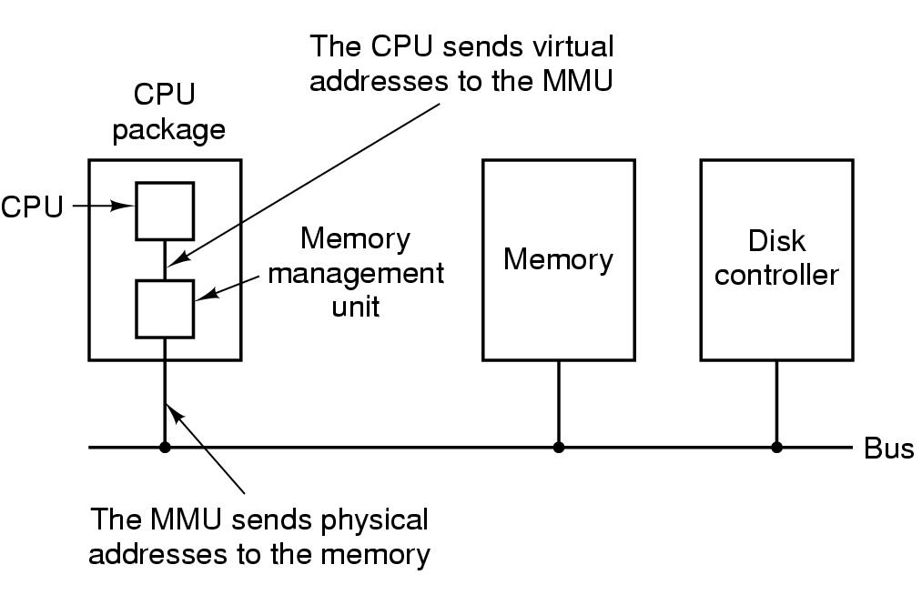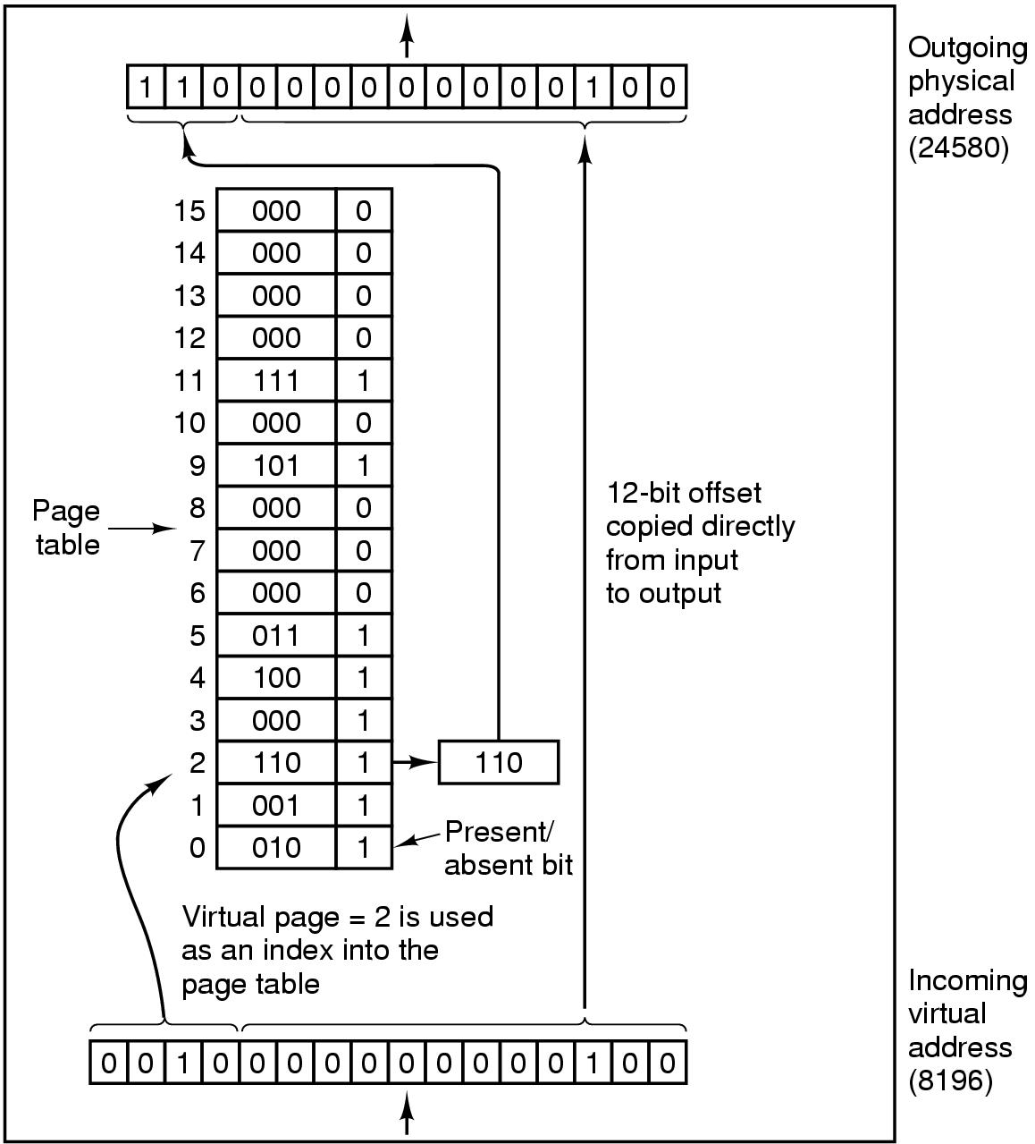
      - Page table entry: page frame number , present/absent bit ( 1 page frame is in memory , 0 page fault), protection : read/write allowed , modified/dirty : write to memory , need to write changes to disk , referenced: is set during read/write used by OS to tell which frames are not used thus evict them , disk address : to load/write pages to disk
      - 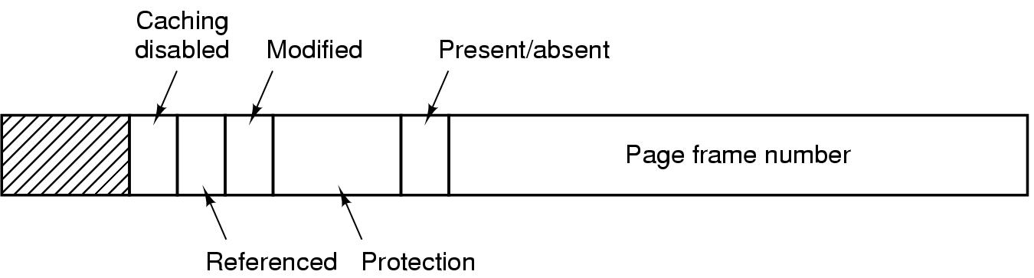
      - Paging implementation issues : 1) mapping virtual to physical should be fast as it’s done for each memory reference 2) if virtual address space is large, page table will be large too , and each process needs its own page table
      - 2 draft solutions : 1)page table is array of registers , no main memory is needed (fast , but expensive in large page table) , 2) keep page table entirely in memory ( can keep more data , but too slow )
      - Translation lookaside buffer / Associative memory (caching):
        - HW device to map virtual address to physical without going to page table ( in memory), it resides inside MMU and has small number of fast entries .Each entry has virtual page # , present bit , modified bit , protection bit , and the physical page frame # 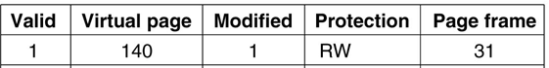
        - When virtual address is asked from MMU , it’ll check TLB first and allow if protection bit accept it, if entry is not in TLB it does the normal page table lookup(memory), and replace one of the TLB entries with the new page info, next time it will result in cache hit .
        - when purging an entry from TLB , it’s flag bits is updated in page table in memory ( e.g. modified )
        - Software TLB : TLB entries are populated by OS ,when TLB miss instead of MMU(HW) to go and load from page table , it’ll trap OS with page fault , OS will do the rest and continue process where it stopped
        - TLB Softmiss :when page is not in TLB but in memory , just update TLB entries
        - TLB hardmiss : when the page itself is not in memory , a disk I/O is needed for swapping (too slow )
        - Page tables for large address space :
          - Multilevel page table : 32bit virtual can be divided :10bit PT1,10bit PT2 , 12 bit offset => 2^20 pages each one is 2^12 (=4KB) size , index first table with PT1 , then index PT2 , and then use offset
          - 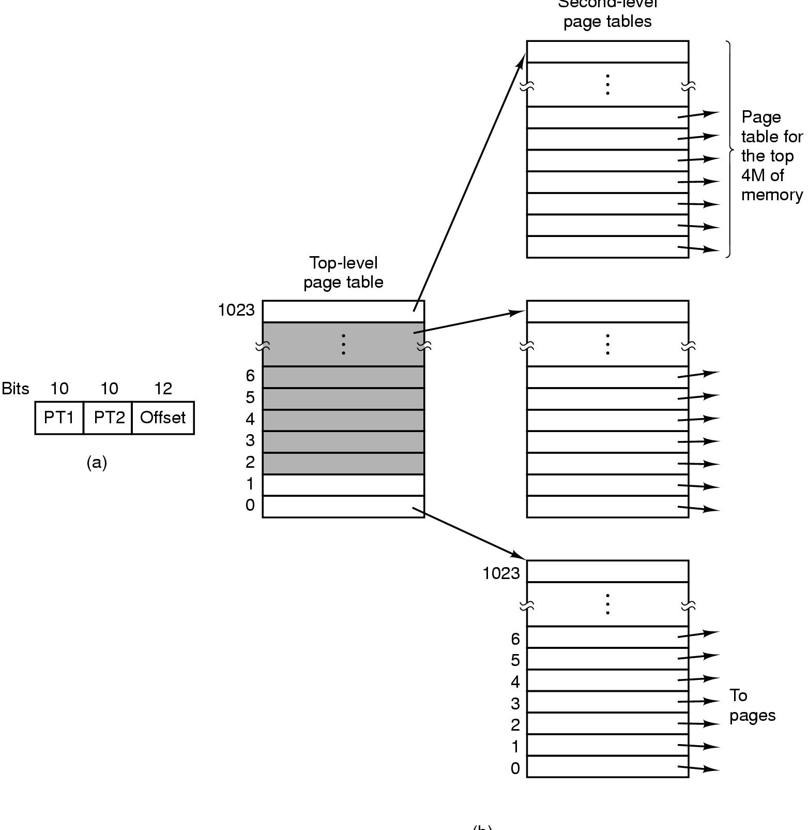
          - In Top level : entry 0 => text , entry 1=>data , entry 1023=>stack , other shaded are not used ( thus need only 4 page tables , top , data,text ,stack)
          - Inverted page table ( for 2^64 address space as page tables will be too large)
          - One entry per page frame in physical memory ( vs an entry per page in virtual address space )
          - The entry keeps track of which virtual page/process is using the physical page frame
          - Pros : they save too much space to store page table specially if virtual space is much larger than physical address space
          - Cons: virtual to physical mapping is much harder , when process n reference page p , HW can no longer find the physical page by indexing p into the table , it has to search entire table to tell if page entry exists (n,p), also this process has to be made for every memory reference (slow)
          - Use TLB (caching ) , can use index direct if TLB entry exists ,when TLB miss , search inverted table
          - To improve searching the inverted table , store as a hash table (by n ) , the entry will be (n,p)
          - 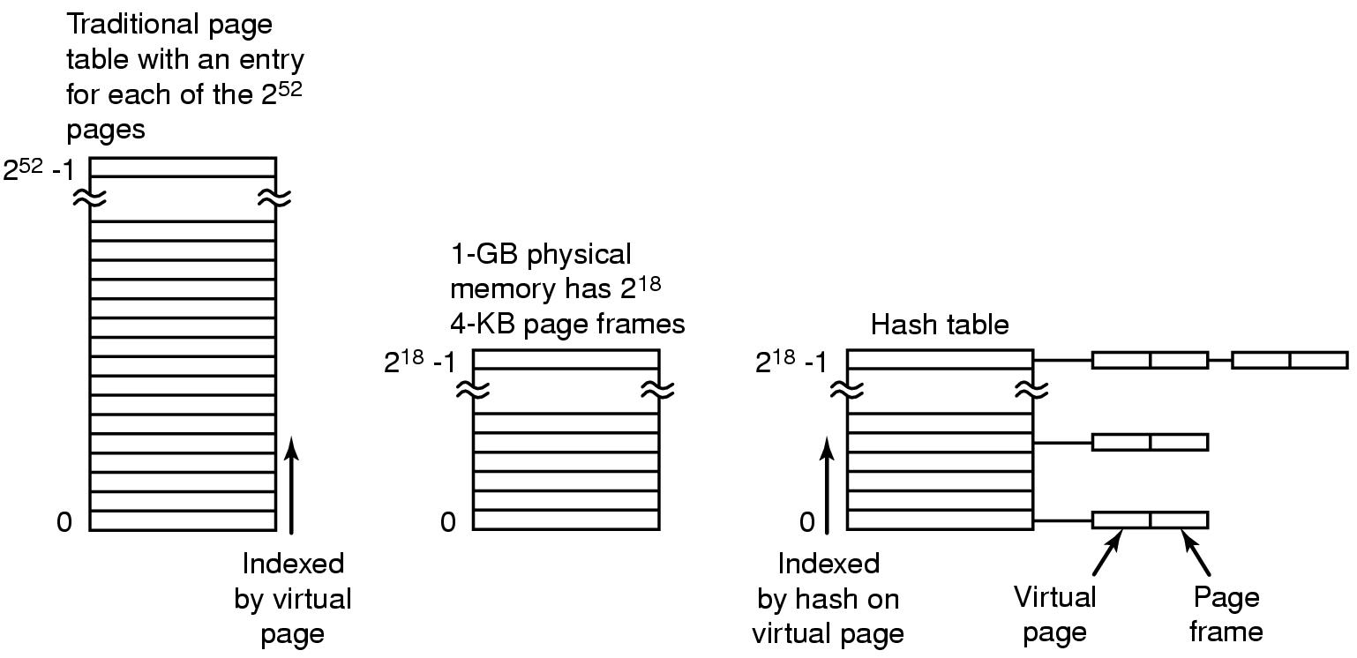
          - Page replacement algorithms : TODO
          - Design issues with page replacement :
          - Local vs global replacement :
            - Each process has multiple page frames , when a page fault happens select the evicted page from only allocated process frames ( local ) , or the lowest age page regardless of the process (global )
            - Local has fixed number of pages for a process , global it could change dynamically .Global works better with a variable working set needs , if local is used and working set increases thrashing could happen
            - If working sets shrinks local result in memory waste
            - How many pages to allocate to a process? divide all available pages number on #of processes equally ( fair but not good) , better is to give #pages based on process size ( larger process ->more pages)
            - For Global : start with #pages suitable for process size , and update allocation (increase/decrease) based on page fault frequency (PFF) . PFF algorithms determine allocation size (#pages) , not which page to replace on fault .Page fault decreases as more pages are available In memory
            - Keep PFF within A,B by changing allocation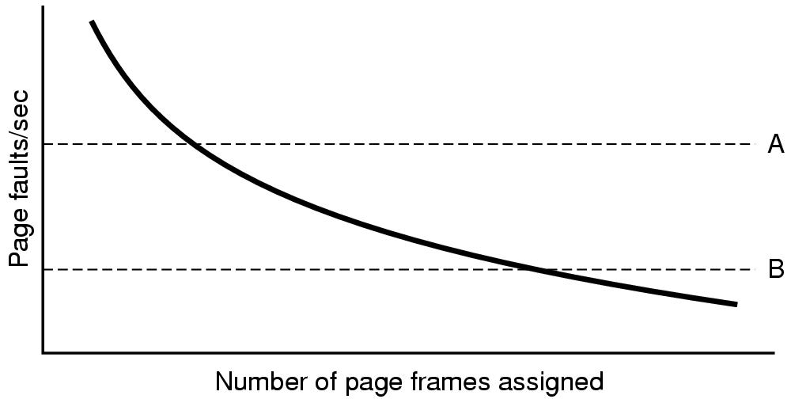
            - Working set /Clock WS only works for local replacement , where is LRU or the like can work on local/global
          - Load control : no matter how efficient memory replacement algorithm is , if all processes /combined working set exceeds memory at the same time thrashing will happen , the only solution is to get rid of some processes
            - A process could be swapped fully into disk , use it’s free page frames for others ,repeat until thrashing stops
            - Thrashing is detected when PFF tell that process needs more pages while no other process need less
          - Page size :
            - Internal fragmentation : large page size lead to memory waste , e.g. stack segment won’t use all page frame
            - Small page size => larger page table ( more entries ) , also disk transfer takes more time ( # of transfer increases)
          - Separate instruction and data space : separate into I-space , D-space , both can be paged independently with it’s own page tables . fetches will go to each one as needed Pros: more virtual space is allowed now
          - 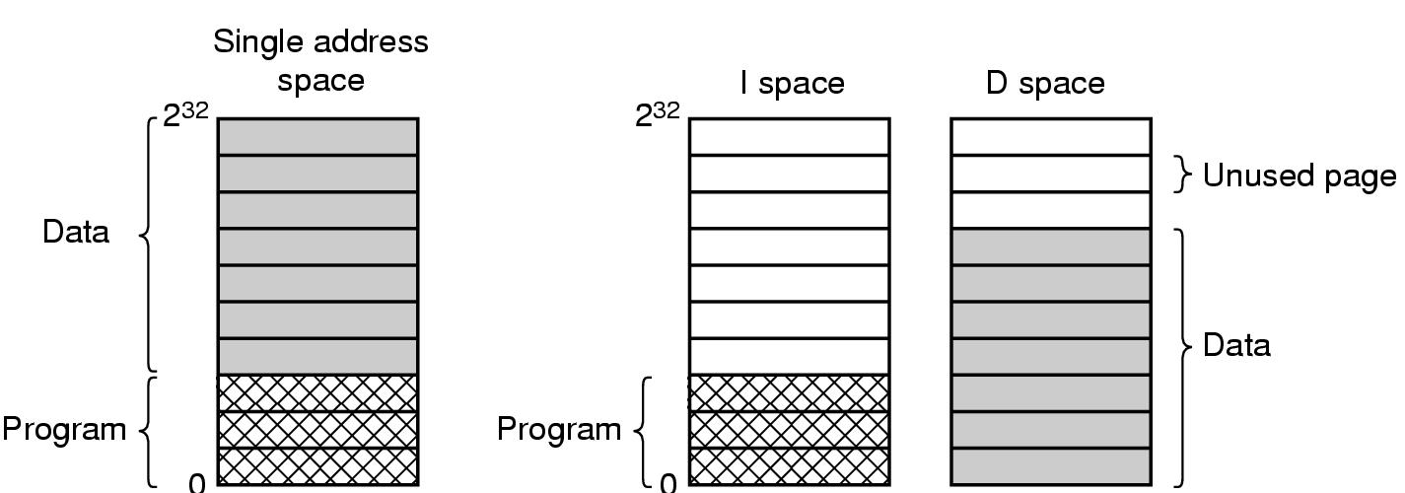
          - Shared pages: in multiprogramming if multiple instance of the same app is running, pages of text(program code )could be shared . if I-space and D-space are used , then easy to share I-space . tracks when to close an instance if there are others thus not evicting the frame ( preventing page faults)
          - To share data , in the beginning mark page as read only , when write create a new separate page(copy on write)
          - Shared libraries (dynamic link lib DLL): when multiple apps are using the same library (text/code) . link will be at runtime at the first shared lib call .
            - Pros : smaller exe files ( not all libs included/linked) . updates in lib get reflected all user apps (no recompilation)
            - Cons: relocation for lib on the fly for each process is not possible , to fix this copy on write is applied( not good )
            - Another option is compile with position independent code : all memory references are relative not absolute
          - Implementation issues (Page Fault handling )
            - The hardware traps to the kernel, saving the program counter on the stack.
            - An assembly code routine is started to save the general registers and other volatile information.
            - The operating system discovers that a page fault has occurred, and tries to discover which virtual page is needed.
            - Once the virtual address that caused the fault is known, the system checks to see if this address is valid and the protection consistent with the access
            - If the page frame selected is dirty, the page is scheduled for transfer to the disk, and a context switch takes place.
            - When page frame is clean, operating system looks up the disk address where the needed page is, schedules a disk operation to bring it in.
            - When disk interrupt indicates page has arrived, page tables updated to reflect position, frame marked as being in normal state.
            - Faulting instruction backed up to state it had when it began and program counter reset to point to that instruction.
            - Faulting process scheduled, operating system returns to the (assembly language) routine that called it.
            - This routine reloads registers and other state information and returns to user space to continue execution, as if no fault had occurred.
          - Backing up instructions: problem at instruction that cases page fault , OS has to restart this instruction when page is ready , but program counter has already incremented . One solution is to have another register to keep old program counter register value
          - If a process is I/O bound , it’s page could be removed , but we still need it . soln: pinning process pages in memory
          - Backing store (where on file system to store swapped pages ), Linux uses SWAP partition ( special partition where no need to map files , just use blocks/chunks in sequence )
            - Swap are list of free chunks. Associate (in process table )with each process it’s swap disk address
            - Reserve separate swap areas for text,data ,stack
            - Static swapping : in the beginning allocate swap for process ( as large as the process virtual space), fixed address is allocated in swap for a process. Cons: finding contiguous swap for all process may not be possible
            - Dynamic swapping : allocate nothing for a process initially and start allocating when needed , cons: an extra mapping table is needed between process and it’s swapping addresses
            - 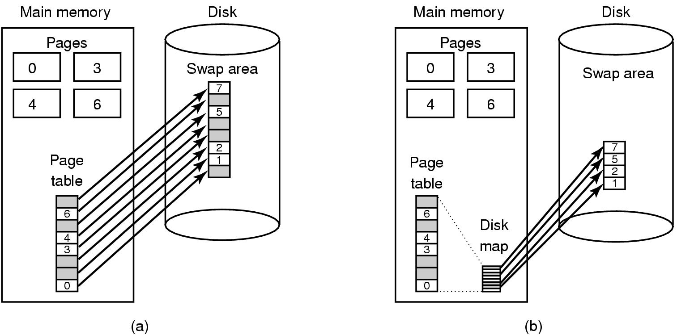
          - Separate policy and mechanism :
            - Memory management system is divided into three parts:
              - A low-level MMU handler.( machine dependent)
              - A page fault handler that is part of the kernel.(machine dependent , mechanism part)
              - An external pager running in user space.( policy part)
            - Pros : flexible and more modular
            - Cons : crossing boundary between users pace and kernel space and extra communication
          - Segmentation:
          - Virtual memory explained so far is one dimensional; address goes from 0 to some maximum. Segmentation allows a process to have more than one virtual address space separately(segments)
          - Each segment has address space 0-max , each segment can have different length , even increase/decrease
          - Program provides 2 part address ( segment number , offset inside segment)
          - Segment are logical entities that programmer uses
          - Pros :
            - Simplified data structures that grows/shrink , give each one a segment ( vs one dimensional where large table/stack could bump into the next)
            - If each procedure has segment , it starts at 0 , linking is much simpler , call procedure (n,0) , n is segment #
            - also changing procedure size won’t others ( Vs one dimension where procedures are located in one space)
            - shared libraries , give a lib a segment and all apps refer to this segment
            - since programmer is aware of different segments as logical units (e.g arrays , stack ,procedure), he can assign different protection flags . Each segment has one type , e.g procedure is execute only , array is read/write ,..
          - Example Compiler need for segmentation :
            - The source text being saved for the printed listing (on batch systems).
            - The symbol table – the names and attributes of variables.
            - The table containing integer, floating-point constants used.
            - The parse tree, the syntactic analysis of the program.
          - The stack used for procedure calls within the compiler.
          - Implementation of pure segmentation : segments different sizes ( vs paging where page size is fixed)
            - External fragmentation (check boarding) : when using/evicting segments from main memory holes starts to happen . it’s wasted memory , one fix is memory compaction
          - Segmentation with paging : if segment is large it won’t even fit in memory , thus page them so that only used pages are in memory => paged segments
          - When a memory reference occurs, the following algorithm is carried out:
            - The segment number used to find segment descriptor.
            - Check is made to see if the segment’s page table is in memory.
            - If not, segment fault occurs.
            - If there is a protection violation, a fault (trap) occurs.
            - Page table entry for the requested virtual page examined.
            - If the page itself is not in memory, a page fault is triggered.
            - If it is in memory, the main memory address of the start of the page is extracted from the page table entry
            - The offset is added to the page origin to give the main memory address where the word is located.
            - The read or store finally takes place.

          - Paging vs segmentation
          - 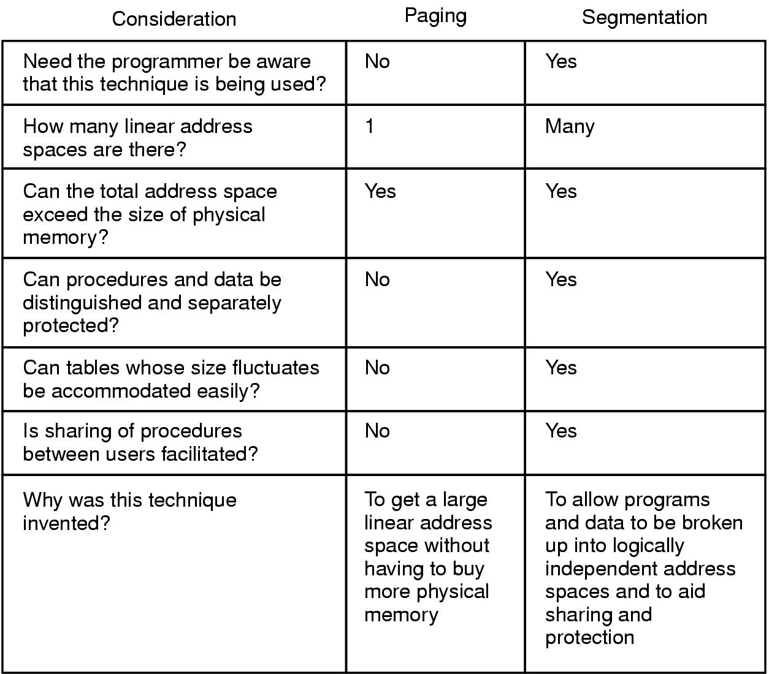

Chapter 4...File systems
- Requirements
  - It must be possible to store a very large amount of information.
  - The information must survive the termination of the process using it.
  - Multiple processes must be able to access the information concurrently.
- Files is the OS way to abstract disks
- Linux is case sensitive regarding file names , Windows is not
- File structure
  - Byte sequence ( Linux and Windows ): Most flexible , apps determine meaning of file
  - Record sequence(fixed length records) : Old systems , read /write one record
  - Sorted Tree records (not the same length): Used to locate a record with a certain key , used in Data processing
- File Types
  - Regular , Directories
  - Character based : Model serial I/O devices like printers
  - Block based : to Model disks (CD)
- Executable file structure
  - Header contains magic number to tell OS a file is executable
  - Text (executable image) size , data size , symbol table (used for debugging),addresses and flags , and relocation bits
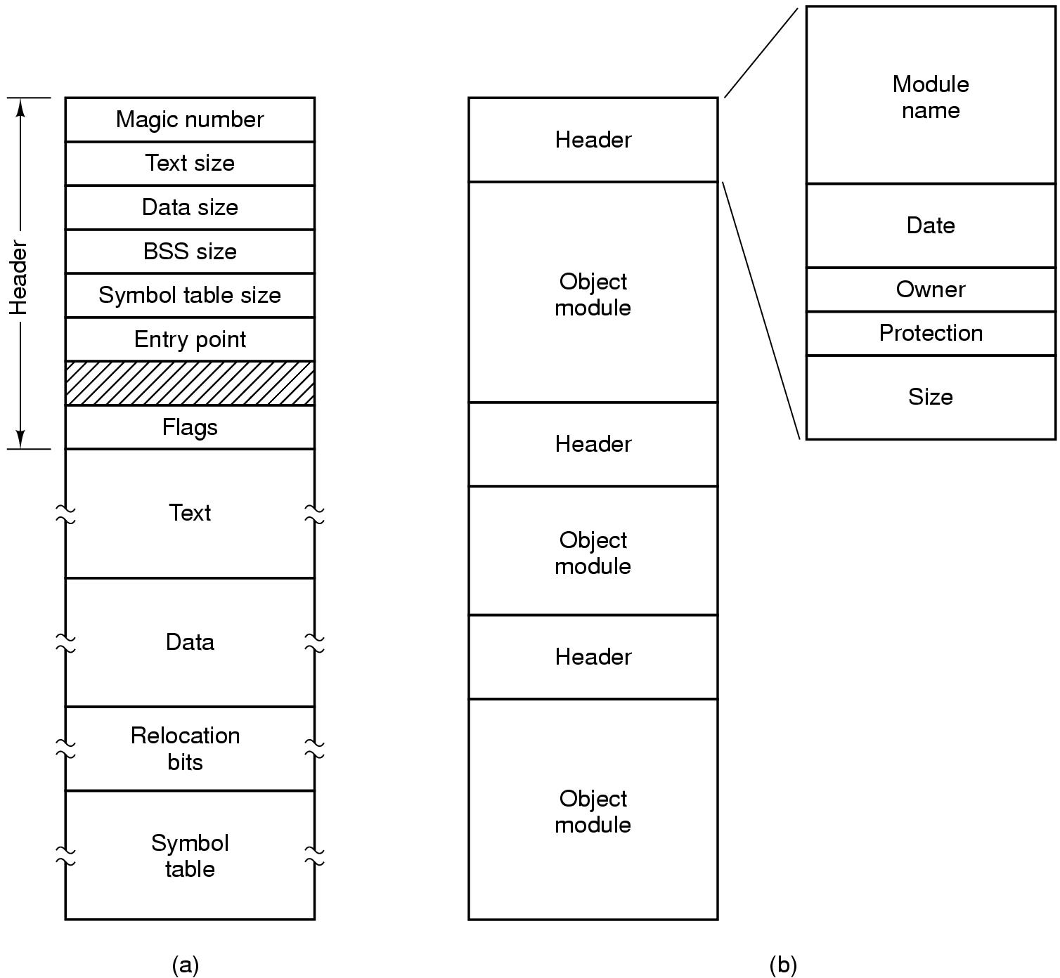
- File access : Sequential or random (via seek )
- File attributes: size, access/protection flags, owner, creation/modification date, password …
- File Operations : read ,append ,seek ,write ,open (return file descriptor, and load file attributes and address in memory), close (to clear memory ), rename , remove, get/set attributes
- Directories organizes into hierarchy , operations create , delete ,un/link
- Path : absolute and relative , set working directory ( not used in libraries as they are shared by multiple apps, it has to revert the working directory)

